
INDUSTRY REPORT
Mining in the US
Feb 2026

About

IBISWorld
IBISWorld specializes in industry research with coverage on thousands of global industries. Our comprehensive data and in-depth analysis help businesses of all types gain quick and actionable insights on industries around the world. Busy professionals can spend less time researching and preparing for meetings, and more time focused on making strategic business decisions.

Table Of Contents | Standard

1. About 4
Codes 4
Definition 4
Related Terms 4
What's Included 5
Companies 5
Related Industries 5
Additional Resources 5
2. At a Glance 6
Key Takeaways 6
Products and Services 7
Major Players 8
Key External Drivers 9
Industry Structure 9
SWOT 10
Executive Summary 10
3. Performance 11
Highlights 11
Key Takeaways 11
Performance Snapshot 12
Outlook 20
Life Cycle 22
4. Products and Markets 23
Key Takeaways 23
Products and Services 24
Major Markets 28
International Trade 30
Imports 33
Exports 34
5. Geographic Breakdown 35
Key Takeaways 35
Business Locations 36
6. Competitive Forces 41
Key Takeaways 41
Concentration 41
Barriers to Entry 42
Substitutes 43
Buyer & Supplier Power 45
7. Companies 47
Key Takeaways 47
Market Share 48
Companies 49
8. External Environment 62
Key Takeaways 62
External Drivers 62
Regulation & Policy 66
Assistance 67
9. Financial Benchmarks 68
Key Takeaways 68
Cost Structure 68
Key Ratios 71
10. Key Statistics 73
Industry Data 73

1. About
https://my.ibisworld.com/us/en/industry/21/about

Codes
NAICS 2017 - USA | 21
NAICS 2022 - USA | 21

Definition
Mining includes the extraction of minerals occurring naturally; solids, including coal and ores; liquids, like crude petroleum; and gases, like natural gas. It also includes quarrying, well operations, milling (e.g., crushing, screening, washing and flotation) and other preparations undertaken at the mine site or as a part of mining activity. The exploration and development of mineral properties are also included.

Related Terms

COKE
Solid residue remaining after certain types of coals are heated to a high temperature out of contact with air until all components that easily vaporize have been driven off.

METALLURGICAL COAL
Coal with a high carbon content used to produce coke for steel making. This type of coal is also referred to as coking coal.

THERMAL COAL
Coal with a high energy content burned as fuel in power stations. This type of coal is also referred to as steaming coal.

ETHANOL
A form of alcohol used as a fuel, which is primarily made from grains like corn and soybeans.

ORGANIZATION OF PETROLEUM EXPORTING COUNTRIES (OPEC)
A global organization consisting of 12 countries and designed to create stability and control in the petroleum markets.

AGGREGATE
Any of several hard materials like crushed rock, sand, gravel, stone, slag, cinders or other inactive materials.

CRUSHED STONE
A form of construction aggregate, typically produced by mining a suitable rock deposit and breaking the removed rock down to the desired size using crushers.

What's Included
- Oil and gas extraction
- Coal mining
- Metal ore mining
- Nonmetallic ore mining or quarrying
- Support services for mining

Companies
- Exxon Mobil Corporation
- Bp Plc
- Conocophillips Co
- Halliburton Company
- Vulcan Materials Company
- Freeport-Mcmoran Inc.

Related Industries

Industries in the Same Sector
- Competitors:
  - No data available
- Complementors:
  - No data available

International Industries
- Coal Mining in New Zealand
- Hard Coal Mining in the UK

Additional Resources
- US Geological Survey
- National Stone, Sand and Gravel Association
- US International Trade Commission
- US Energy Information Administration
- World Coal Association

2. At a Glance
https://my.ibisworld.com/us/en/industry/21/at-a-glance
Revenue  $686.6bn  ’21-’26 ↓ 1.2 %  ’26-’31 ↓ 0.3 % | Employees  590k  ’21-’26 ↑ 1.7 %  ’26-’31 ↓ 0.6 % | Businesses  77,270  ’21-’26 ↓ 2.1 %  ’26-’31 ↓ 1.4 %
Profit  $199.1bn  ’21-’26 ↑ 0.7 % | Profit Margin  29.0%  ’21-’26 ↑ 2.6 pp | Wages  $63.8bn  ’21-’26 ↑ 2.3 %  ’26-’31 ↓ 0.5 %

Key Takeaways

Performance
- The Bipartisan Infrastructure Act has significantly bolstered the need for nonmetallic mining materials, essential for large-scale infrastructure projects. This government spending has provided a reliable opportunity for growth in highway and bridge construction, which has led to more revenue for miners.
- The growing popularity of renewable energy presents both challenges and benefits. It cuts into oil and gas revenue but boosts profit for metallic miners by bolstering the need for minerals used in green technologies. The One Big Beautiful Act cut various tax credits, which will weaken competiiton through 2032.

Products and Markets
- Mining companies will exhibit hikes in purchasing costs amid new tariffs on steel. This will cause equipment prices to go up (think drills and haul trucks). Companies will need to price their products accordingly to keep up with costs or force operational cutbacks or expansions.
- Chinese tariffs on coal and other materials may make these goods unavailable to Chinese buyers. With exports to China already at risk, domestic oversupply could depress prices, forcing layoffs or even mine closures.
- Because natural gas is available and affordable, US coal consumption has dropped, prompting miners to seek international markets. Export-friendly regulations have supported this shift, keeping coal miners afloat.
- Construction markets faced interest rate swings. Low interest rates during the pandemic spurred residential construction, increasing the need for materials like crushed stone, sand and gravel. Even so, rebounding interest rates have since slowed development despite government infrastructure support.

Products and Services
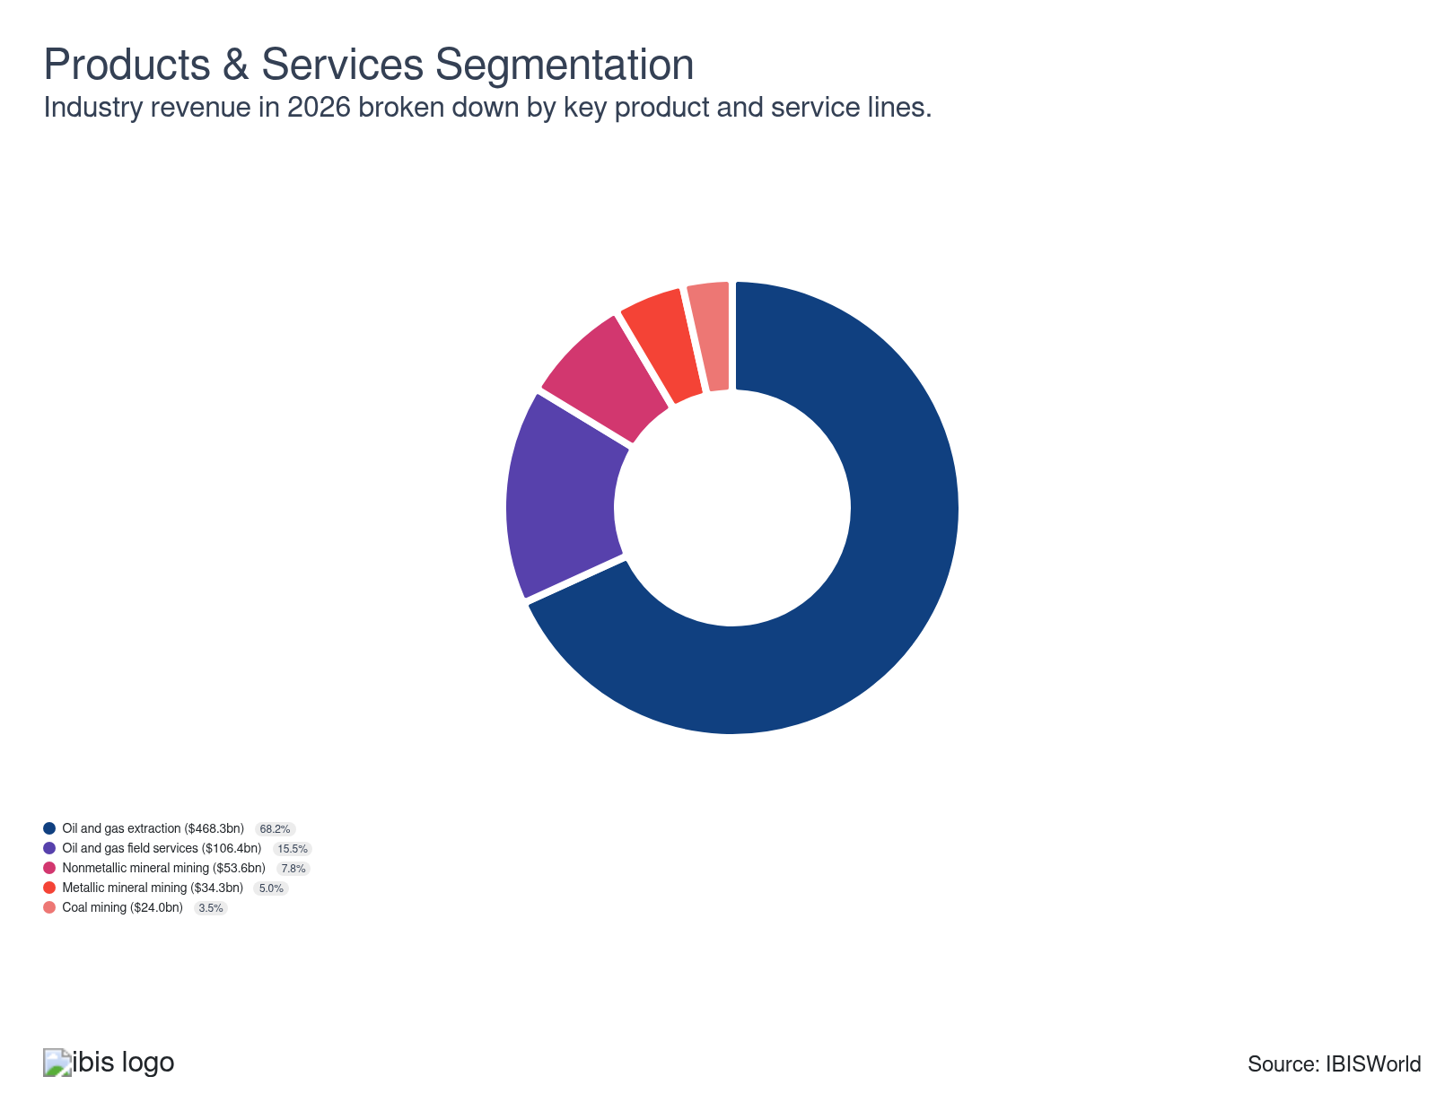

Major Players
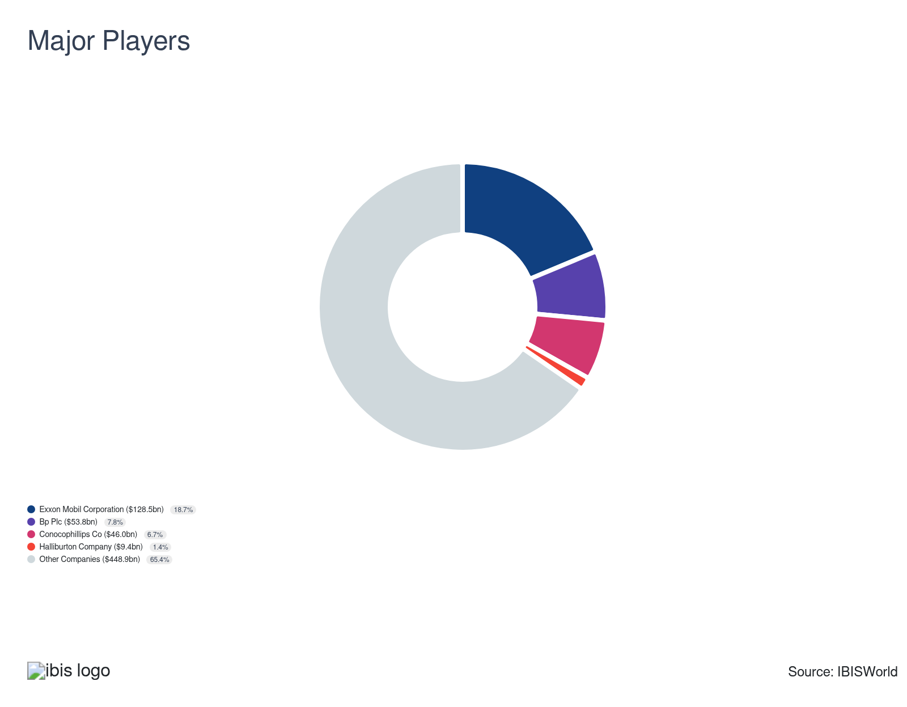

Key External Drivers
Key External Drivers | Impact
World price of crude oil | Positive
Electric power consumption | Positive
Trade-weighted index | Negative
World price of natural gas | Positive
Industrial production index | Positive
World price of coking coal | Positive

Industry Structure
Characteristic | Level | Trend
Concentration | Low
Barriers To Entry | High | Steady
Regulation and Policy | High | Increasing
Life Cycle | Mature
Revenue Volatility | High
Assistance | Low | Steady
Competition | High | Steady
Innovation | Low

SWOT
Strengths  High Profit vs. Sector Average | Weaknesses  Very High Volatility  High Customer Class Concentration  High Product/Service Concentration  Low Revenue per Employee  High Capital Requirements | Opportunities  High Revenue Growth (2021-2026)  High Revenue Growth (2026-2031)  High Performance Drivers | Threats  Low Revenue Growth (2005-2026)  Low Outlier Growth  Trade-weighted index

Executive Summary

Mining deep: Falling commodity prices will cause sector revenue to return to normal levels
Oil and gas activities generate an overwhelming share of sector revenue and tend to dictate the performance of the entire sector. In recent years, domestic producers have begun adopting hydraulic fracturing and directional drilling techniques, which has enabled the US to become a world-class energy producer. Energy exports have also significantly boosted miners’ performance, as the US remains the world's largest gas exporter. The period started off hot as the economy recovered, prices surged, bolstering sector-wide revenue and profitability. Nonetheless, prices eventually fell back, leading to revenue contraction toward the end of the period. Overall, sector-wide revenue has pushed down at a CAGR of 1.2% through 2026, reaching $686.1 billion, including a 5.2% dip in 2026 alone.
International trade has been a bright spot for the sector, as exports surged during the period. The US continues to ramp up domestic production and has become one of the world's largest exporters. In 2022, Russia's invasion of Ukraine spiked oil and gas prices as European countries placed sanctions on the country's energy exports. After these Russian sanctions, domestic oil and gas production ramped up to take advantage of favorable pricing amid low supply in Europe. The US has already outpaced its oil exports in 2025, compared to the previous year and does not look to slow down as production capacity is set to double by 2029. Coal mining has also been a major export market for miners, as countries like India and China rely heavily on coal to generate electricity.
Miners will face contractions over the outlook period as commodity prices regress. International trade will continue providing a vital source of growth, particularly for coal and hydrocarbon producers. Even so, President Trump's recent tariffs may cause countries like Canada and China to place retaliatory tariffs, weakening some of their largest export markets. Even so, infrastructure investment will remain a consistent source of growth for miners, as the Infrastructure Investment and Jobs Act provides funding for roads, highways and utilities. Some minerals may also see an uptick in production, as the US Department of the Interior added ten new minerals to the critical mineral list to alleviate future supply issues. Overall, sector revenue is set to push down at a CAGR of 0.3% to $676.6 billion through the end of 2031.

3. Performance
https://my.ibisworld.com/us/en/industry/21/performance

Highlights
Revenue  $686.6bn  2021-26 CAGR ↓ 1.2 %  2026-31 CAGR ↓ 0.3 % | Employees  590k  2021-26 CAGR ↑ 1.7 %  2026-31 CAGR ↓ 0.6 % | Businesses  77,270  2021-26 CAGR ↓ 2.1 %  2026-31 CAGR ↓ 1.4 %
Profit  $199.1bn  2021-26 CAGR ↑ 0.7 % | Profit Margin  29.0%  2021-26 CAGR ↑ 2.6 pp

Key Takeaways
- The Bipartisan Infrastructure Act has significantly bolstered the need for nonmetallic mining materials, essential for large-scale infrastructure projects. This government spending has provided a reliable opportunity for growth in highway and bridge construction, which has led to more revenue for miners.
- The growing popularity of renewable energy presents both challenges and benefits. It cuts into oil and gas revenue but boosts profit for metallic miners by bolstering the need for minerals used in green technologies. The One Big Beautiful Act cut various tax credits, which will weaken competiiton through 2032.

Performance Snapshot
Revenue: | ↓ 2021-26 Revenue CAGR -1.2%
Revenue  $686.6bn  ’21-’26 ↓ 1.2 %  ’26-’31 ↓ 0.3 % | 2026 Revenue Growth  ↓ 5.2 % | Revenue Volatility  High
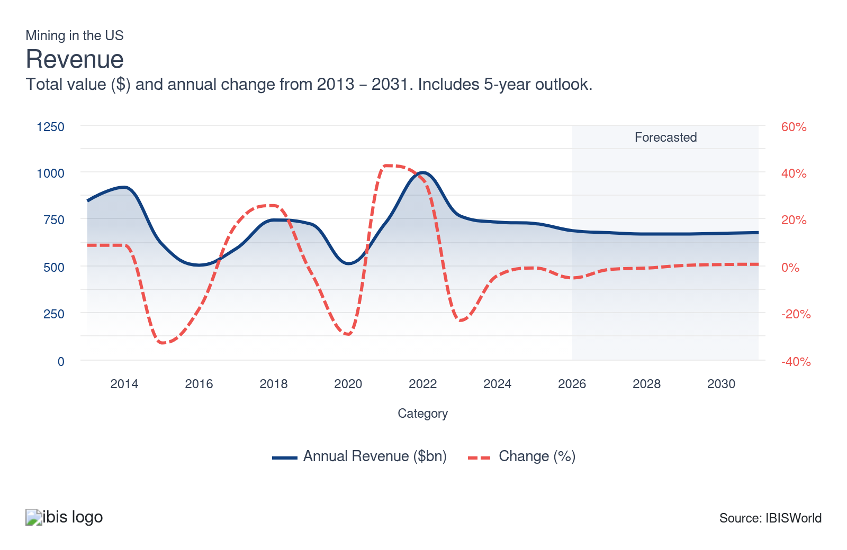
Employees: | ↑ 2021-26 Employees CAGR +1.7%
Employees  590k  ’21-’26 ↑ 1.7 %  ’26-’31 ↓ 0.6 % | Employees per Business  8  ’21-’26 ↑ 3.8 %  ’26-’31 ↑ 0.8 % | Revenue per Employee  $1m  ’21-’26 ↓ 2.8 %  ’26-’31 ↑ 0.3 %
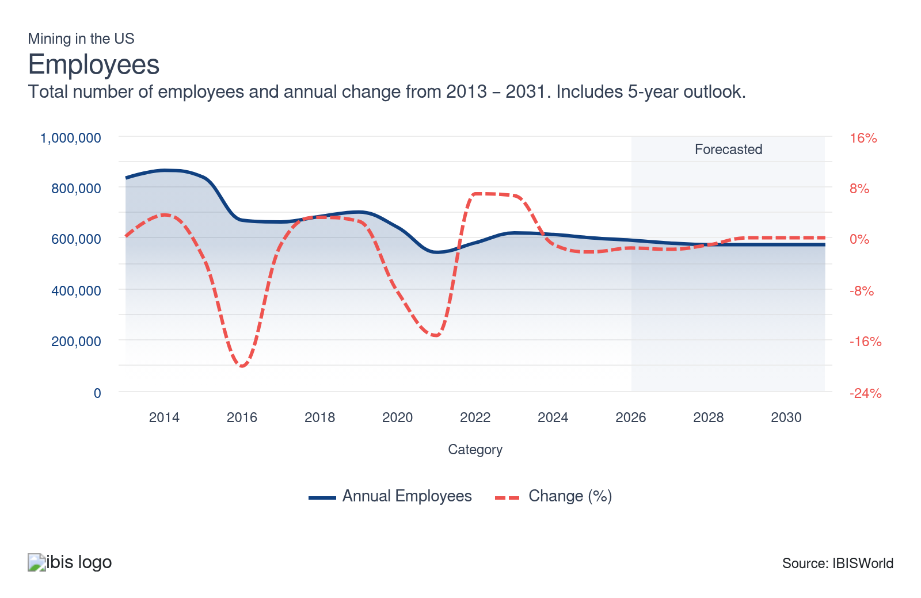
Businesses: | ↓ 2021-26 Business CAGR -2.1%
Businesses  77,270  ’21-’26 ↓ 2.1 %  ’26-’31 ↓ 1.4 % | Employees per Business  8  ’21-’26 ↑ 3.8 %  ’26-’31 ↑ 0.8 % | Revenue per Business  $8.9m  ’21-’26 ↑ 0.9 %  ’26-’31 ↑ 1.1 %
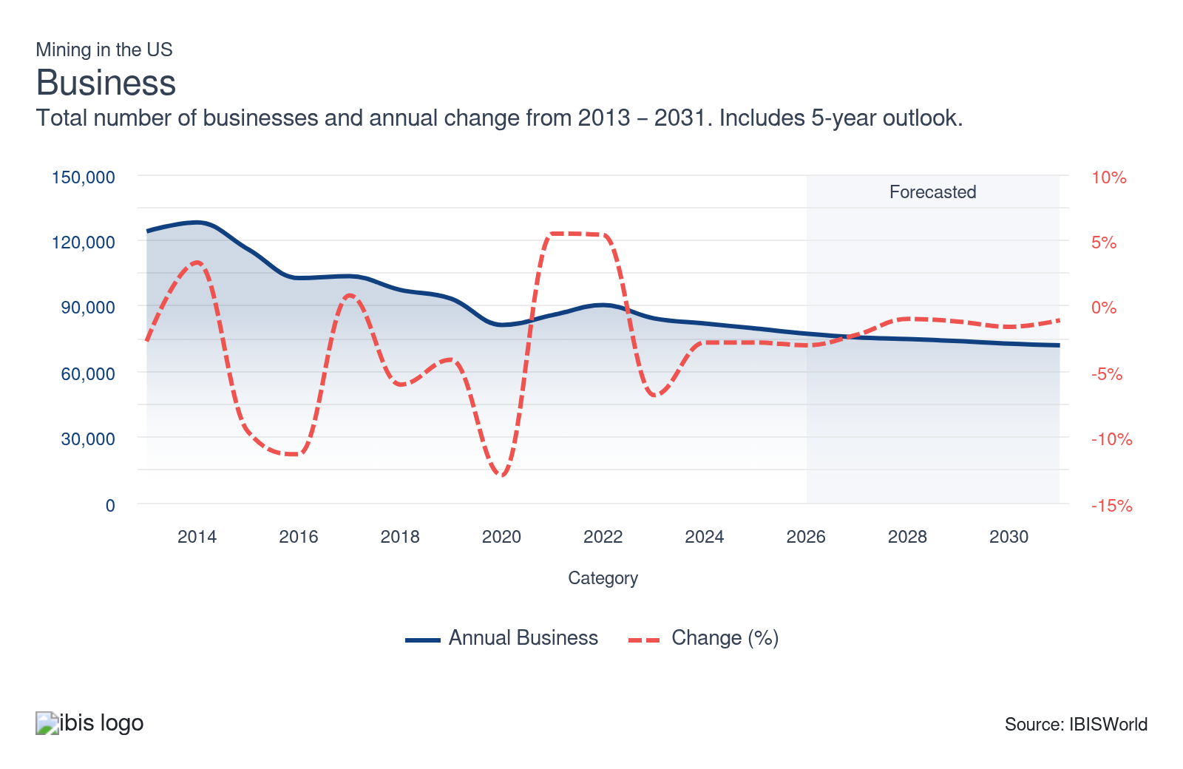
Profit: | ↑ 2021-26 Profit CAGR +0.7%
Total Profit  $199.1bn  ’21-’26 ↑ 0.7 % | Profit Margin  29.0%  ’21-’26 ↑ 2.6 pp | Profit per Business  $2.6m
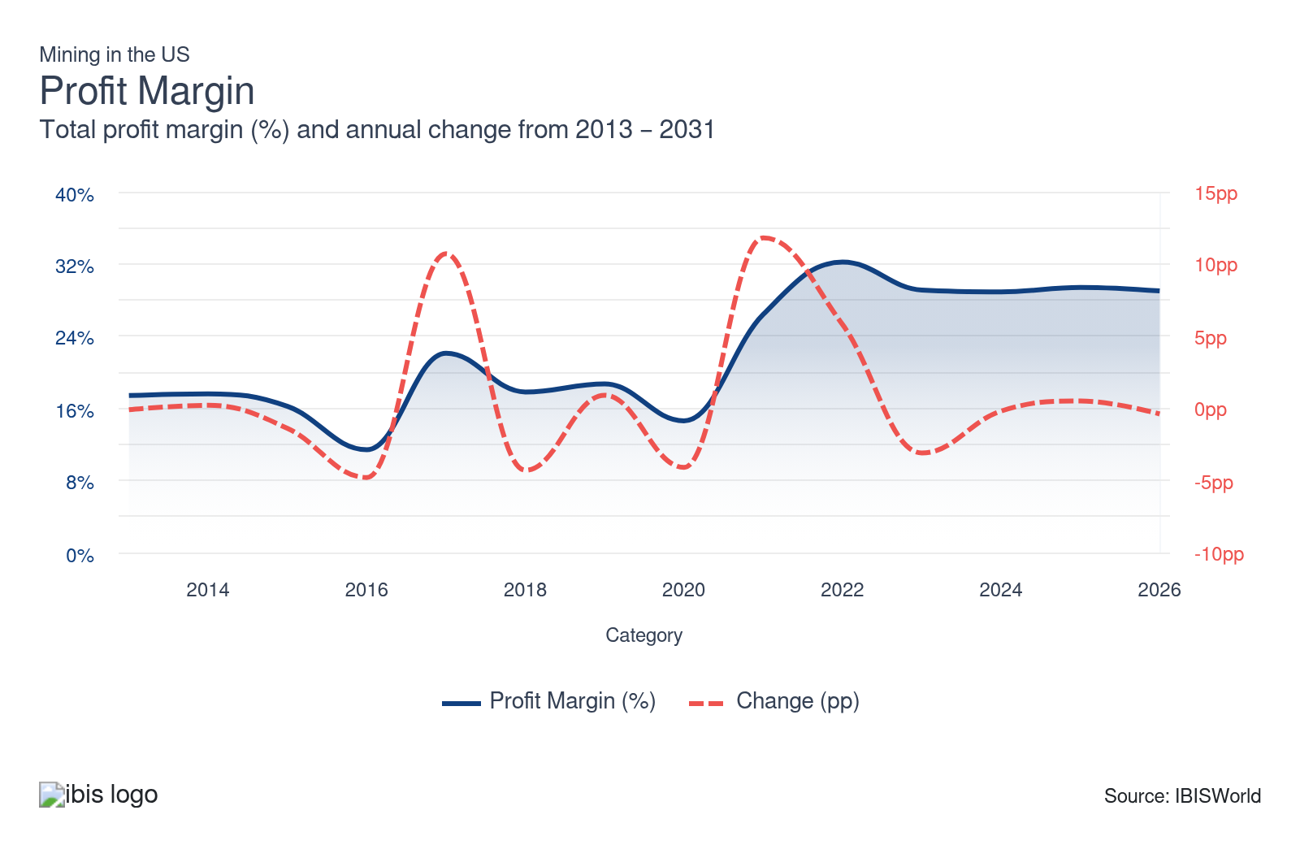
Current Performance
Current Performance

What's driving current industry performance?

International trade becomes a reliable revenue stream
- The widespread adoption of more productive oil and gas field extraction techniques has allowed US production to far exceed domestic consumption. Beginning in 2015, oil and gas producers could only sell to foreign countries following the repeal of the Energy Policy and Conservation Act. As of 2025, exports account for over a quarter of revenue and has pushed up 5.0% from 2020.
- Sanctions on Russian energy amid the Russia-Ukraine conflict bolstered exports from Europe. The Nord Stream 1 and 2 pipeline explosion significantly reduced Europe's natural gas supply from Russia, forcing Europe to look to the US to satisfy their energy needs. The Netherlands' need for oil and gas surged, making it the largest export destination.
- In 2025, the US remained the largest exporter of natural gas, as export volumes increased annually since 2014. According to the US Energy Information Administration, for the first nine months of 2025, domestic liquified natural gas export volumes outpaced the same period in the previous year.

Metallic miners see shakeups amid recovery
- While gold and silver benefited right before the start of the period because of economic uncertainty, this quickly changed as the economy recovered. Nonetheless, recent uncertainty surrounding geopolitical and economic issues has caused gold and silver to surge in price towards the end of 2025, as they are safe-haven investments. Silver is also used in various industrial activities and its scarcity has contributed to the price hike.
- As steel production resumed at the start of the period, the need for iron ore surged domestically and globally, particularly in China. This enabled iron ore miners to raise prices, salvaging revenue they had missed out on during lockdowns. As supply chains stabilized, the price of steel gradually dipped from post-pandemic highs. Even so, prices remained elevated, ensuring a steady flow of revenue and profit.
- The recent growth is also because of the Bipartisan Infrastructure Act, which mandates that projects use domestically sourced iron ore and steel. The $1.2 trillion Infrastructure Investment and Jobs Act upgrades U.S. infrastructure, driving the need for iron ore in projects like bridge and highway construction through various programs.

Key construction markets drive growth for nonmetallic mining
- Surging residential construction in the middle of the current period spiked the need for sand, gravel granite, limestone, trap rock and talc, bolstering growth for stone and gravel miners. Sand miners also benefited from the reopening of the industrial sector after the pandemic, as the price of industrial sand surged.
- Interest rate hikes subdued growth in the residential construction market toward the end of the current period as rising inflation deterred investment. The federal funds rate peaked at 5.5% from July 2023 through August 2024. Rates have been pushed down slightly in September, November and December of 2024 and again late 2025. As of January 2026, it remains at 3.75%, making mining projects a bit more feasible than earlier in the period.
- The Bipartisan Infrastructure Law passed in 2021, has greatly benefited the mining sector by bolstering the need for many nonmetallic materials required for these projects through its $1.2 trillion in funding through 2026. This has been the one bright spot for nonmetallic miners as the Mineral Commodity Summaries 2025 noted an 8.0% gain in highway construction spending in the first nine months of 2024 compared to the same period in 2023.

Renewable energy is a mixed bag
- With the majority of the revenue in this sector stemming from oil and gas companies, the push for renewable energy has slowly constrained growth. Companies are seeking more ways to be environmentally friendly, and transitioning to renewable energy sources is one of the easier ways to do so. According to the latest data available from the Energy Information Administration, renewable energy has risen in popularity and accounts for over one-fifth of the revenue from electricity produced in 2023.
- The Inflation Reduction Act extended government incentives for renewable energy, primarily through tax credits. These measures aim to make the switch to renewable energy more financially feasible, attracting numerous customers and businesses previously deterred by high costs. Nonetheless, the One Big Beautiful Bill Act ended residential tax credits in 2025, with production tax credits set to expire in 2026 and 2027, weakening a major competitor of fossil fuels.
- Renewable portfolio standards mandate that a certain portion of a state's energy must come from renewable sources. This compels energy companies to incrementally boost their utilization of green energy sources. The rise of renewable energy could pose challenges for the oil and gas industry, but it's been advantageous for metallic miners. Metals like copper, lithium, nickel and zinc are essential for clean energy technologies. Electric vehicles rely on copper and nickel for batteries and wiring, while solar cells and wind turbines require copper and zinc for their conductivity and corrosion resistance. While the One Big Beautiful Bill Act may reduce the competitiveness of renewables, these minerals will still be needed for various technologies.

What influences industry volatility?

Commodity prices induce volatility
- Revenue in the mining sector is directly tied to commodity prices. When demand for a commodity or mineral spikes, so does its price, allowing companies to charge more for their products. Sector revenue swelled at the start of the year as stay-at-home orders lifted and prices spiked, particularly for oil and gas, driving revenue to surge after the pandemic.
- Nonetheless, as supply chain issues calmed, prices for various minerals and commodities (mainly oil and gas) also fell, causing overall revenue to drop during the period, as sustained declines since 2023 erased gains from 2021 to 2022.

Goverment actions can go both ways
- The recently passed Bipartisan Infrastructure Act allocated significant funding for infrastructure improvements, primarily targeting roads and highways. This shift enhances the need for nonmetallic minerals and could lead to more natural resource extraction activities.
- Nonetheless, renewable energy policies like the Inflation Reduction Act incentivize households and businesses to transition to greener alternatives, placing pressure on traditional oil and gas companies. This dual focus on infrastructure and renewable incentives creates a complex landscape that can generate opportunities and challenges for the sector.
- The One Big Beautiful Bill Act has cut residential tax credits in 2025 and is set to cut production and investment tax credits on various energy sources in 2026 and 2027. While this may boost oil and gas production moving forward, it may have a slight impact on minerals used to produce equipment such as solar panels and batteries.
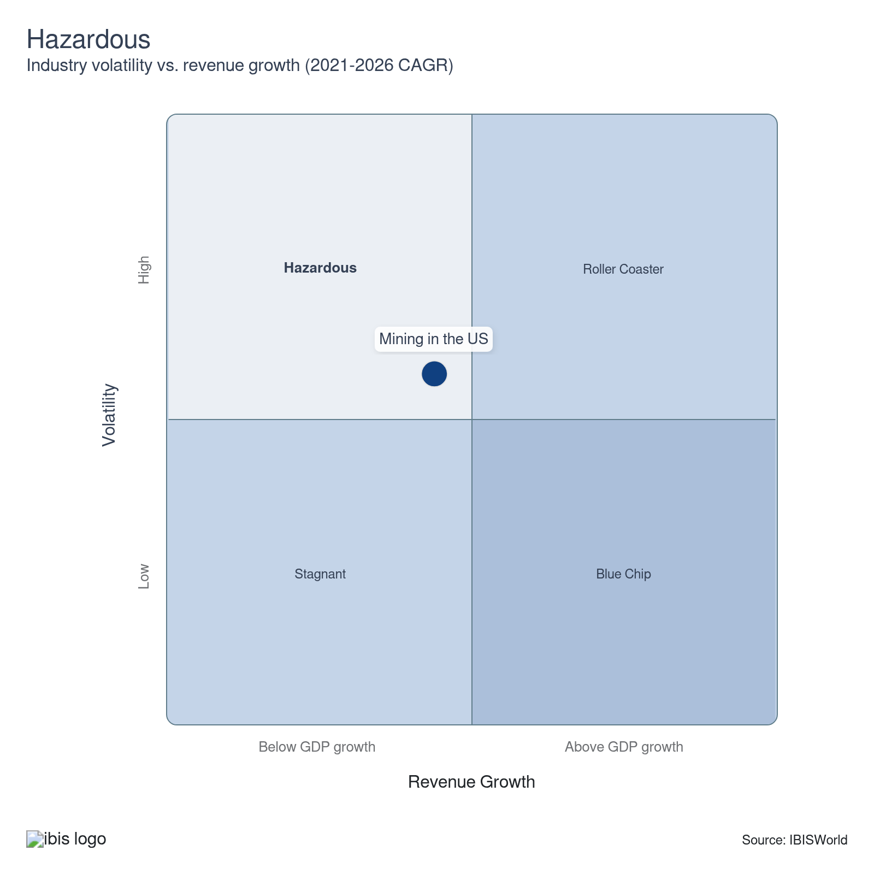

How do successful businesses overcome volatility?
Optimize operating capacity
By fine-tuning operating capacity, miners can quickly adapt to changing demand. This agility helps in managing costs and maximizing output during both high and low market phases.
Control total supply on market
Managing the supply levels helps mining companies influence market prices and stabilize revenue. Companies that dominate the supply of specific minerals within a regional market often hold a transport cost and marketing advantage over competition outside the regional market.
Outlook | ↓ 2026-31 Revenue CAGR -0.3%

What's driving the industry outlook?

Prices come back down to earth
- As global supply chains stabilize and production resumes, oil and gas prices are set to dip. The expansion in renewable energy adoption will moderate prices as consumers and businesses pursue alternatives to fossil fuels. Even so, high volatility will persist because of the unpredictable nature of geopolitical events, weather patterns and future economic developments.
- As prices come down, oil and gas companies will generate less revenue as their position in the sector shrinks slightly. Even so, profitability will remain elevated since input costs for heavy machinery will dip, reducing expenses. Nonetheless, these input cost dips may not be as drastic because of President Trump's 25.0% tariffs on steel and aluminum.
- While these tariffs will boost domestic steel manufacturing, various companies in the sector that purchase materials may exhibit a temporary uptick in prices in 2025 and possibly 2026, which will slightly constrain any profit growth. Oil drillers, gas extractors and mining companies would have to adjust their own pricing to keep their profit steady.
- Companies will also implement cost-saving technologies like automation (think robotics, artificial intelligence and machine learning) to cut wages and bolster profitability. While companies have enjoyed the cost-savings of hydraulic fracturing, the technology's future will remain in the air because of its detrimental environmental impacts.

Energy exports to continue to drive demand
- Uncertainty surrounding Europe's energy supply will be a boon for the mining sector since Europe has historically depended on Russia for coal, oil and natural gas and it will need a new source to satisfy its energy needs. Because of the Russia-Ukraine conflict, the future of LNG transport from Russia to Europe is uncertain because of the reliance on pipelines through Ukraine. Without a new contract, Europe may need alternative LNG sources. A large portion comes from the U.S. and Europe might boost these imports to counter potential disruptions from Russia.
- Future trade negotiations between the United States and China could benefit coal miners, particularly during China's trade war with Australia. Increases in domestic regulations will also support coal exports since investment in clean coal technologies is not very cost-effective. Even so, this remains up in the air because of China's projected 15.0% tariff on US coal, which may cause domestic coal miners to set their sights on India, which is the second largest coal importer in the world.
- A depreciation in the US dollar will make domestic commodities and minerals less expensive for foreign buyers. It also weakens the impact of import penetration since they become more expensive. While the overall value of exports is set to dip, this is because of falling prices, as exports as a share of revenue will climb.
- The US remains a major natural gas exporter and is not expected to slow down anytime soon. With production set to double capacity by 2029, trade will continue to remain vital for miners.

Changing interest rate levels to induce volatility
- Higher interest rates compounded by falling commodity prices will expand consolidation early over the outlook period. Larger miners that have significantly benefitted from the favorable price environment in recent years can incur additional costs associated with financing new mining operations. Acquiring smaller companies will help them achieve economies of scale while expanding their domestic footprint.
- Many miners may put off purchasing heavy machinery or implementing the latest technology until rates cool down. Other companies may choose to rent instead of buying to cut costs. High interest rates will hinder the performance of gold and silver miners early since investing in products that accrue interest when interest rates are higher is more profitable.
- While rates are projected to slightly creep down, there is too much uncertainty regarding the economy at the current moment. Inflationary risk remains, particularly under policies from the second Trump administration. Aggressive trade policies, like higher tariffs, could expand import costs, disrupt supply chains and elevate inflationary pressures, keeping rates steady for the time being. This may weaken production in various industries across the mining sector, as companies don't want to deal with these costs, causing a scale back.

Infrastructure investment to be a consistent source of business
- The Investment and Jobs Act signed in 2021 will provide $550.0 billion in funding for highways, bridges and other infrastructure through 2026, with $350.0 billion directly for highway programs. Sand and gravel miners and stone miners will enjoy consistent growth from this investment over the next few years.
- Solid growth in several other infrastructure markets, like the railroad, pipeline and water supply markets, will bolster the growth of crushed stone miners. An expansion in utility infrastructure, particularly power lines, will aid copper miners because of its conductive properties. This helps minimize electricity loss during transmission.
- Nonetheless, the rebound in construction growth may not be as significant as anticipated if interest rates remain steady or decrease more slowly than expected. President Trump's tariffs will tighten project budgets, prompting construction companies to cut costs where possible and cut down the number of projects. This, in turn, will lower the need for various metallic and nonmetallic materials. However, the slowdown won't be too drastic, so miners will still maintain a solid stream of revenue. Miners that serve the construction will still look to diversify their markets or scale back on production incase they see dips in revenue.
Life Cycle | Mature

Why is the industry mature?

Contribution to GDP
IVA has been slightly outpacing GDP, as the industry is very volatile despite many minerals and commodities being essential. Miners have faced various supply shocks as prices skyrocketed at the start of the period, only to fall as supply issues were resolved.

Market Saturation
The industry's large size and dispersion across the nation contribute to the high number of oil and gas companies within the industry because it's difficult for even the largest oil companies to control more than a small share of output.

Innovation
Production from oil drilling and gas extraction companies (IBISWorld report 21111) has been booming compared to other industries in the sector in recent years because of significant accelerations in technological innovation. Advanced drilling techniques have made it easier to extract these commodities, but they come at a cost since they are detrimental to the environment.

Consolidation
Larger companies continue to acquire smaller companies as rising interest rates and price volatility create an operating environment where smaller companies can’t absorb the additional costs associated with capital investment or price hikes. From 2021 to 2031, the number of establishments are set to push down at a CAGR of 1.7%.

Technology & Systems
Advanced techniques, like longwall mining and heap leaching, continue to evolve. Companies are prioritizing enhanced oil recovery practices to optimize production and maintain market competitiveness. Automation has also assisted miners with more dangerous tasks while improving safety for workers. These technologies also help companies reduce wages and indirectly bolster profitability.

4. Products and Markets
https://my.ibisworld.com/us/en/industry/21/products-and-markets
Largest Market  $468.3bn  Oil and gas extraction | Product Innovation  Low

Key Takeaways
- Mining companies will exhibit hikes in purchasing costs amid new tariffs on steel. This will cause equipment prices to go up (think drills and haul trucks). Companies will need to price their products accordingly to keep up with costs or force operational cutbacks or expansions.
- Chinese tariffs on coal and other materials may make these goods unavailable to Chinese buyers. With exports to China already at risk, domestic oversupply could depress prices, forcing layoffs or even mine closures.
- Because natural gas is available and affordable, US coal consumption has dropped, prompting miners to seek international markets. Export-friendly regulations have supported this shift, keeping coal miners afloat.
- Construction markets faced interest rate swings. Low interest rates during the pandemic spurred residential construction, increasing the need for materials like crushed stone, sand and gravel. Even so, rebounding interest rates have since slowed development despite government infrastructure support.

Products and Services
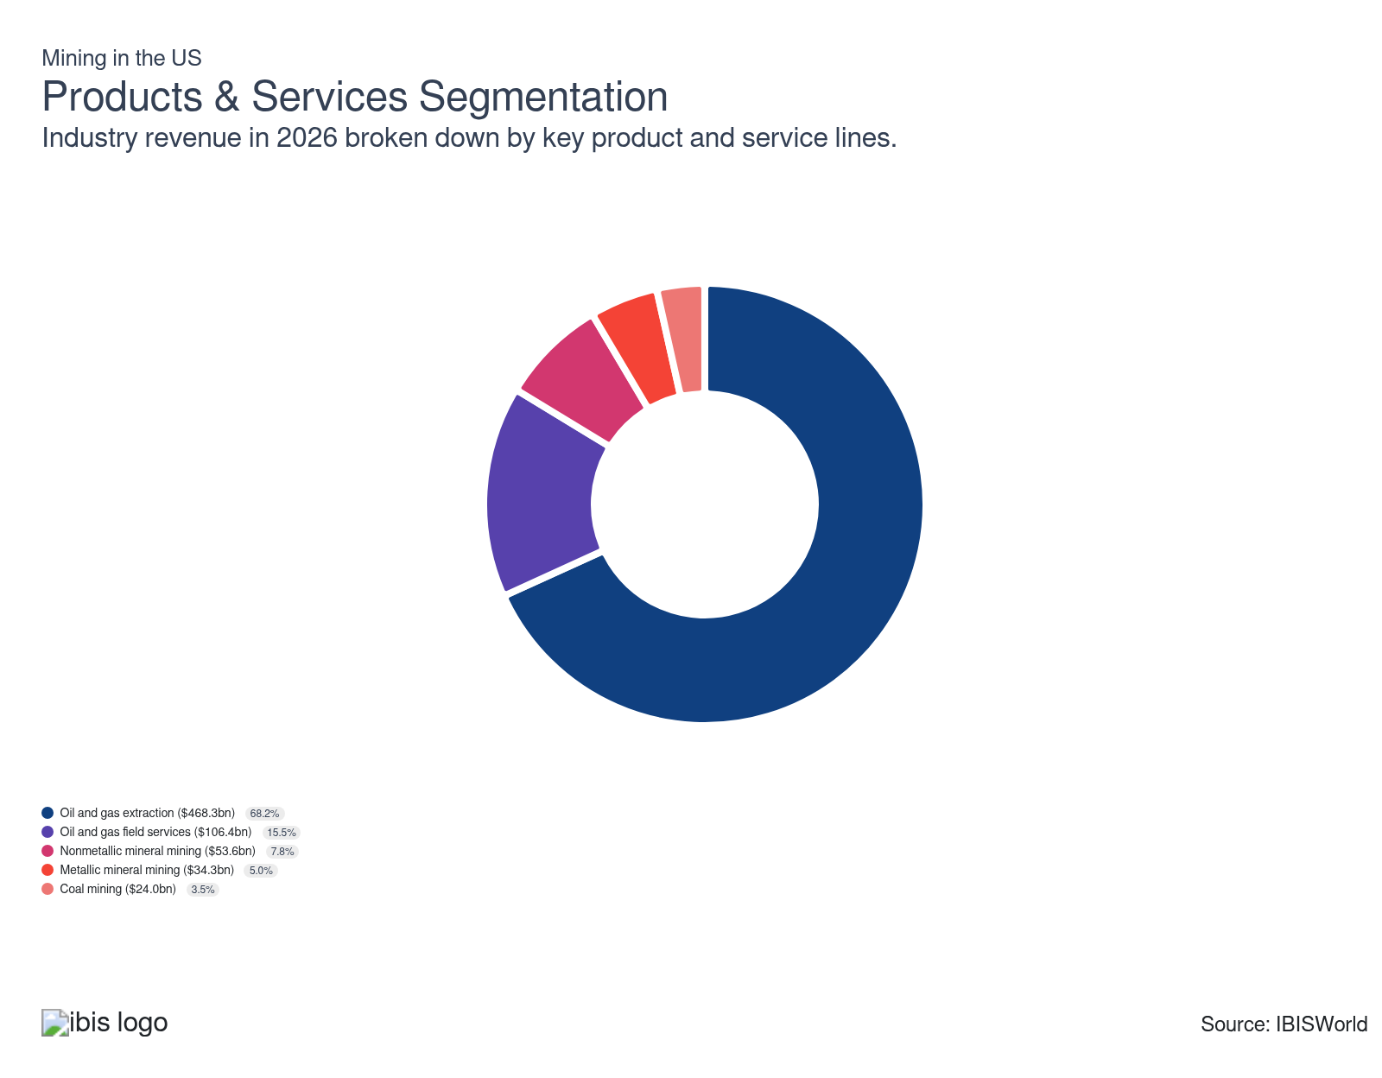

How are the industry’s products and services performing?

Oil and gas extractors enjoyed price-based gains
- This segment drills to extract oil and gas. This segment has been highly susceptible to disruptions in global energy markets and shifts in general macroeconomic conditions. The pandemic led to considerable price volatility as prices plummeted in 2020 amid travel restrictions and lower industrial activity. As the economy reopened, prices surged and the need for travel resumed.
- The industrial sector, which relies on oil and gas for production, also slowly began to operate near total capacity, bolstering revenue as prices went through the roof. While prices have gradually leveled off, they remain elevated. In 2023, the US held the spot of the world's largest crude oil and natural gas producer.

Rising efficiencies weaken the need for support activities
- This segment is responsible for providing drilling and general support services for oil and natural gas extraction activities and assisting with mine exploration and mineral ore extraction. Support activity companies have become less integral as each well has become more efficient.
- While support activities have become less essential, new energy producers seeking to adopt the most efficient and technologically advanced production methods will seek out support service providers.

International trade supports coal miners
- US coal mines extract four primary types of coal: lignite, subbituminous, bituminous and anthracite.
- Bituminous coal has a high carbon content and is commonly used for power and steel production. Subbituminous coal, the second-lowest grade of coal, is mainly used as steaming coal for power generation. Lignite is the lowest-quality coal used for power generation and less commonly for agriculture.
- The rising availability and affordability of natural gas have led to lower US coal consumption for energy, leading coal miners to look overseas as a pathway to growth. Domestic regulations have supported coal exports as many power producers look to reduce their usage.

Mixed results in downstream markets impacted nonmetallic ore miners
- Nonmetallic ore mining includes the mining of potash, borate, phosphate, gypsum, stone, sand and gravel. The housing market boom bolstered the need for stone, sand and gravel miners, but interest rate hikes have slowed this expansion toward the end of the period.
- Steady road and highway construction growth has been a boon to sand and gravel miners. The Biden administration's infrastructure bill and other various government funding like the Fixing America's Surface Transportation (FAST) Act have aided this segment.

Economic conditions impact metallic mining
- Metallic ore mining involves extracting minerals and metals like gold, silver, lead, palladium, uranium, iron, copper, nickel, lead, molybdenum and other metallic commodities.
- Gold and silver ore miners enjoyed growth amid the pandemic as they were considered safe investments amid economic uncertainty and a strong hedge against inflation. With inflation still looming, the need for these minerals has held up.
- Iron ore mining surged as steel prices skyrocketed after lockdown restrictions were lifted. As supply chains began to stabilize, prices slowly dipped, reducing the need for iron ore.

What are innovations in industry products and services?

Technological innovations improve efficiencies for miners
- Mining equipment and processes have streamlined significantly because of technological advances, allowing for real-time production monitoring. Integrating autonomous vehicles in mining has emerged as a critical innovation, enhancing safety and operational efficiency.
- Autonomous vehicles improve fuel efficiency and productivity while significantly reducing instances of unscheduled maintenance. These innovations enhance working conditions and minimize driver fatigue, ultimately fostering a safer and more efficient mining environment.

Innovations in oil and gas extraction enhance efficiency but raise environmental concerns
- Hydraulic fracturing and horizontal drilling have revolutionized oil and gas extraction by allowing companies to access previously unreachable reserves, increasing production from areas deemed depleted. These advanced techniques allow for more targeted drilling, maximizing yield and reducing operational costs.
- Even so, the widespread use of these methods has sparked growing environmental concerns, including potential water and air pollution impacting public health. Critics argue that while these innovations boost energy supplies, they may pose significant risks to ecosystems and community well-being.

What products or services do successful businesses offer?
Forward sell production when appropriate
By locking in prices and buyers for future production, mining companies can mitigate market volatility and secure predictable revenue streams. This strategic move helps manage financial risks and ensures consistent cash flow to support operations and growth.
Invest in new technology to enhance operational efficiency and quality
The most effective and efficient technology can help companies in this sector reduce costs while improving output and bolstering worker safety.

Major Markets
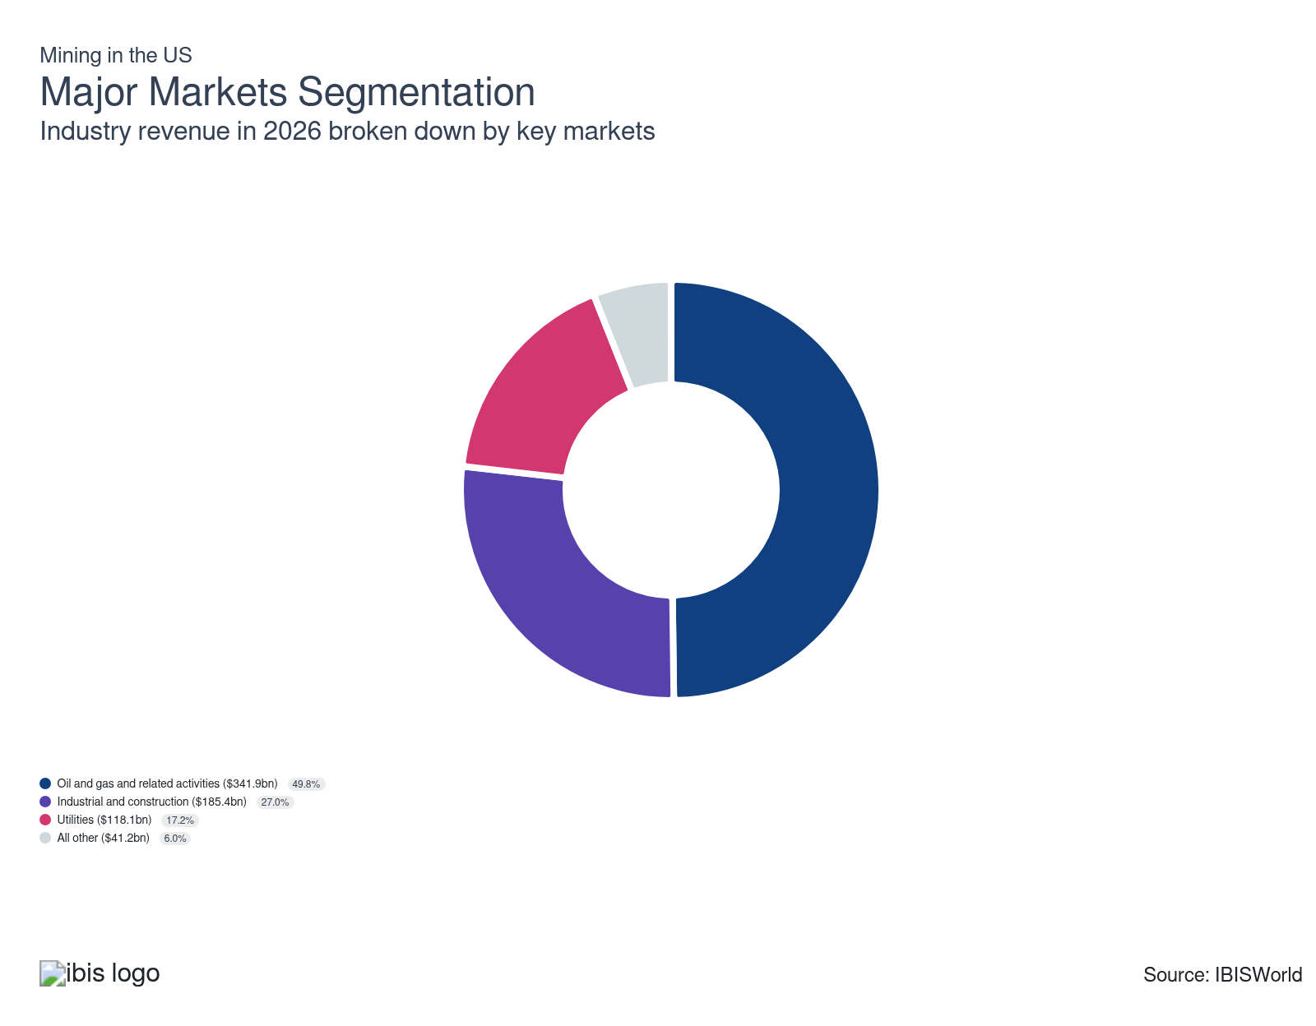

What’s influencing demand from the industry’s markets?

Miners enjoy growth from oil, gas and related activities
- Crude oil is sent to refineries while natural gas gets sent to process. Afterward, these commodities are sent to various groups of end markets.
- Greater domestic exploration of unconventional energy resources has contributed to profound growth in US production of oil and natural gas. Surging prices have also increased output and growth in this market.
- This segment also received a boost from the transportation sector as the need for oil and gas surged after lockdown restrictions were lifted.

Interest rate levels induced volatility in the industrial and construction markets
- The construction and industrial markets are composed of crushed stone, sand and gravel, which is the principal material commodity used in the base, sub-base and surface pavement roads in the United States.
- Many infrastructure, residential, nonresidential and other construction activities use sector products. Low interest rates during the pandemic bolstered residential construction, causing the need for stone, sand and gravel to swell.
- While growth persisted after lockdowns were lifted, rising interest rates amid inflationary concerns caused developers to push back on projects. Even so, government assistance for infrastructure via the Bipartisan Infrastructure continued to remain a bright spot.

Utilities have increasingly sought out natural gas producers
- This market comprises utilities and independent power producers. Regulations restricting coal usage and coal miners’ output have led to natural gas being the primary growth driver in this market. While utilities still look to coal miners, increasingly stringent regulations continue to spur coal exports.
- This segment has suffered slightly as renewable energy has gained traction, pushing utility companies away from fossil fuels.

A wide variety of end users contributes to consistent demand from all other markets
- This segment includes users of products like soda ash, potash, rock salt, boron, molybdenum and palladium.
- Soda ash is a primary raw material input within glass production, as well as inorganic chemicals, soaps and detergents. Potash is used primarily as an agricultural fertilizer. The agricultural sector uses large quantities of potash along with additional nutrients.
- Rock salt is principally used for the de-icing of highways and is purchased from mining companies by state highway authorities and municipal agencies. Industrial producers, like automobile parts manufacturers, purchase platinum group metals (PGMs) for auto catalysts and catalytic converters.

International Trade
Total Imports  $164.1bn  ’21-’26 ↓ 0.7 %  ’26-’31 ↓ 0.4 % | Total Exports  $196.9bn  ’21-’26 ↑ 1.5 %  ’26-’31 ↓ 0.2 % | Trade Balance  Net Exporter  ↑ Surplus: $32.8bn

International Trade Imports
International Trade Imports
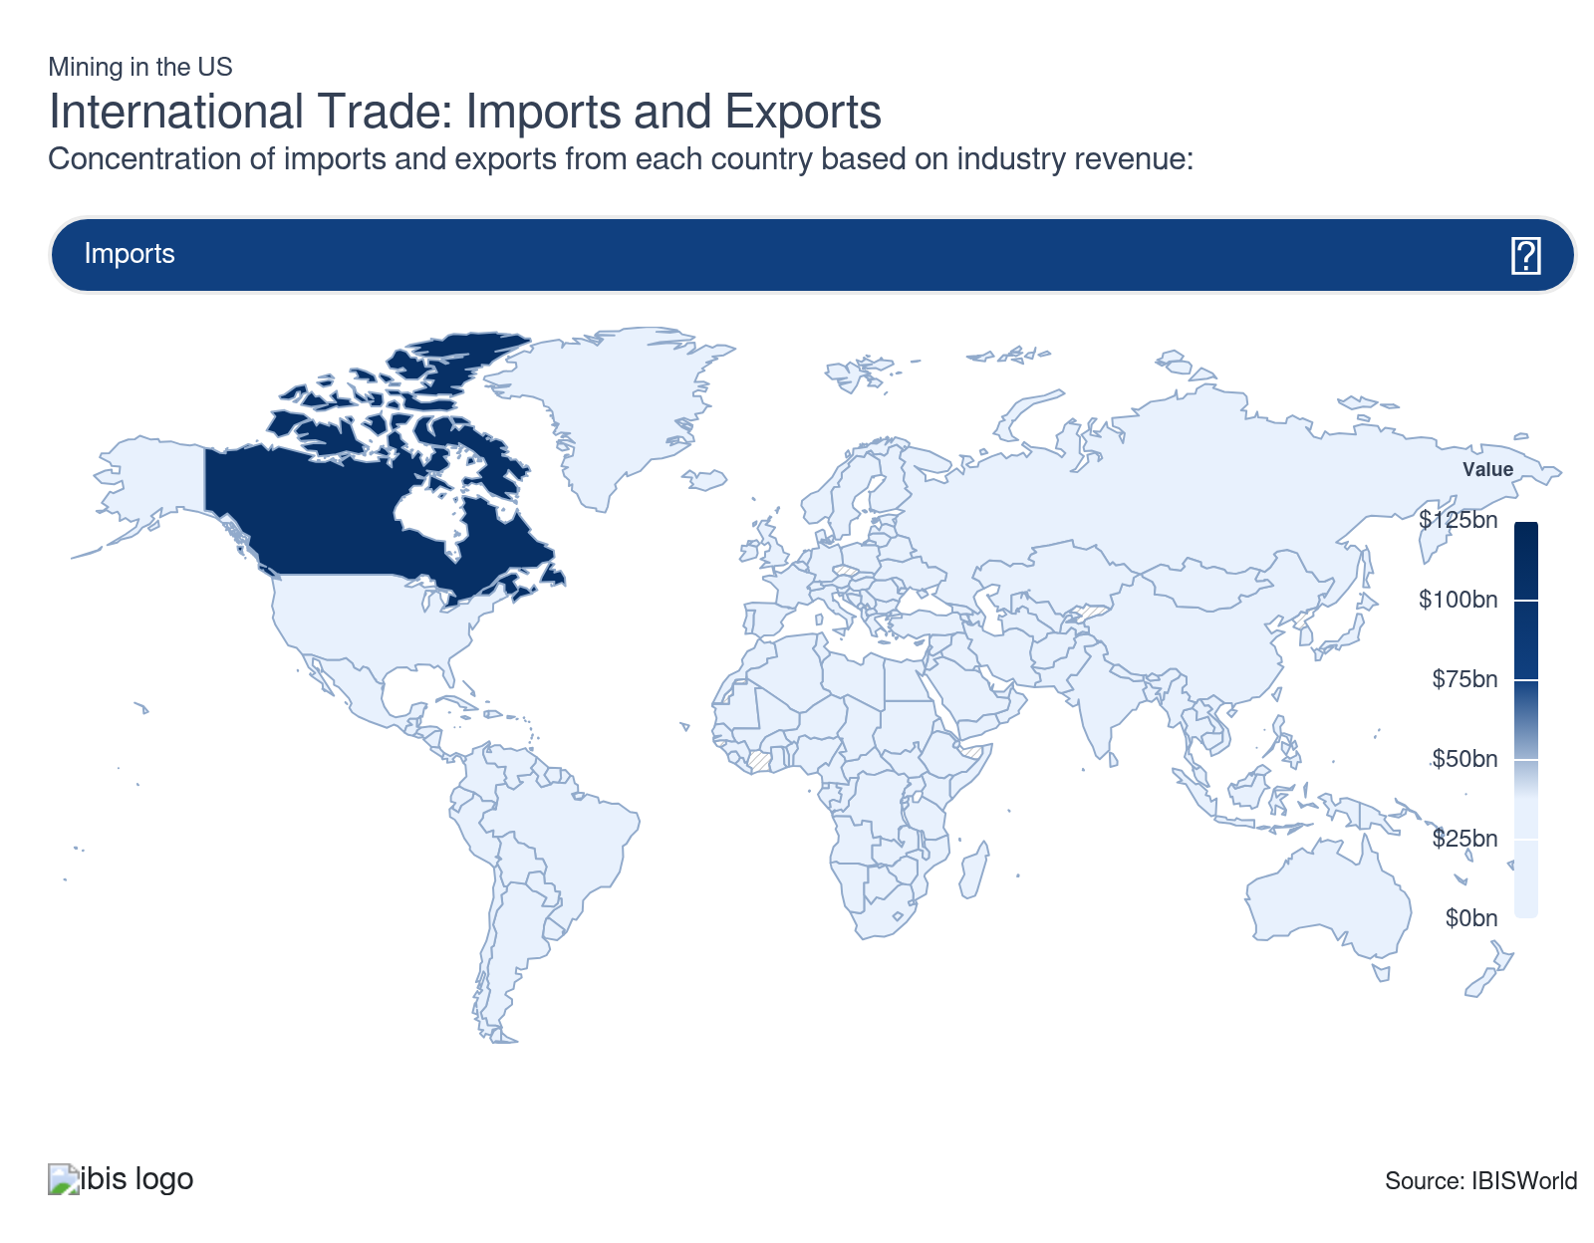
International Trade Exports
International Trade Exports
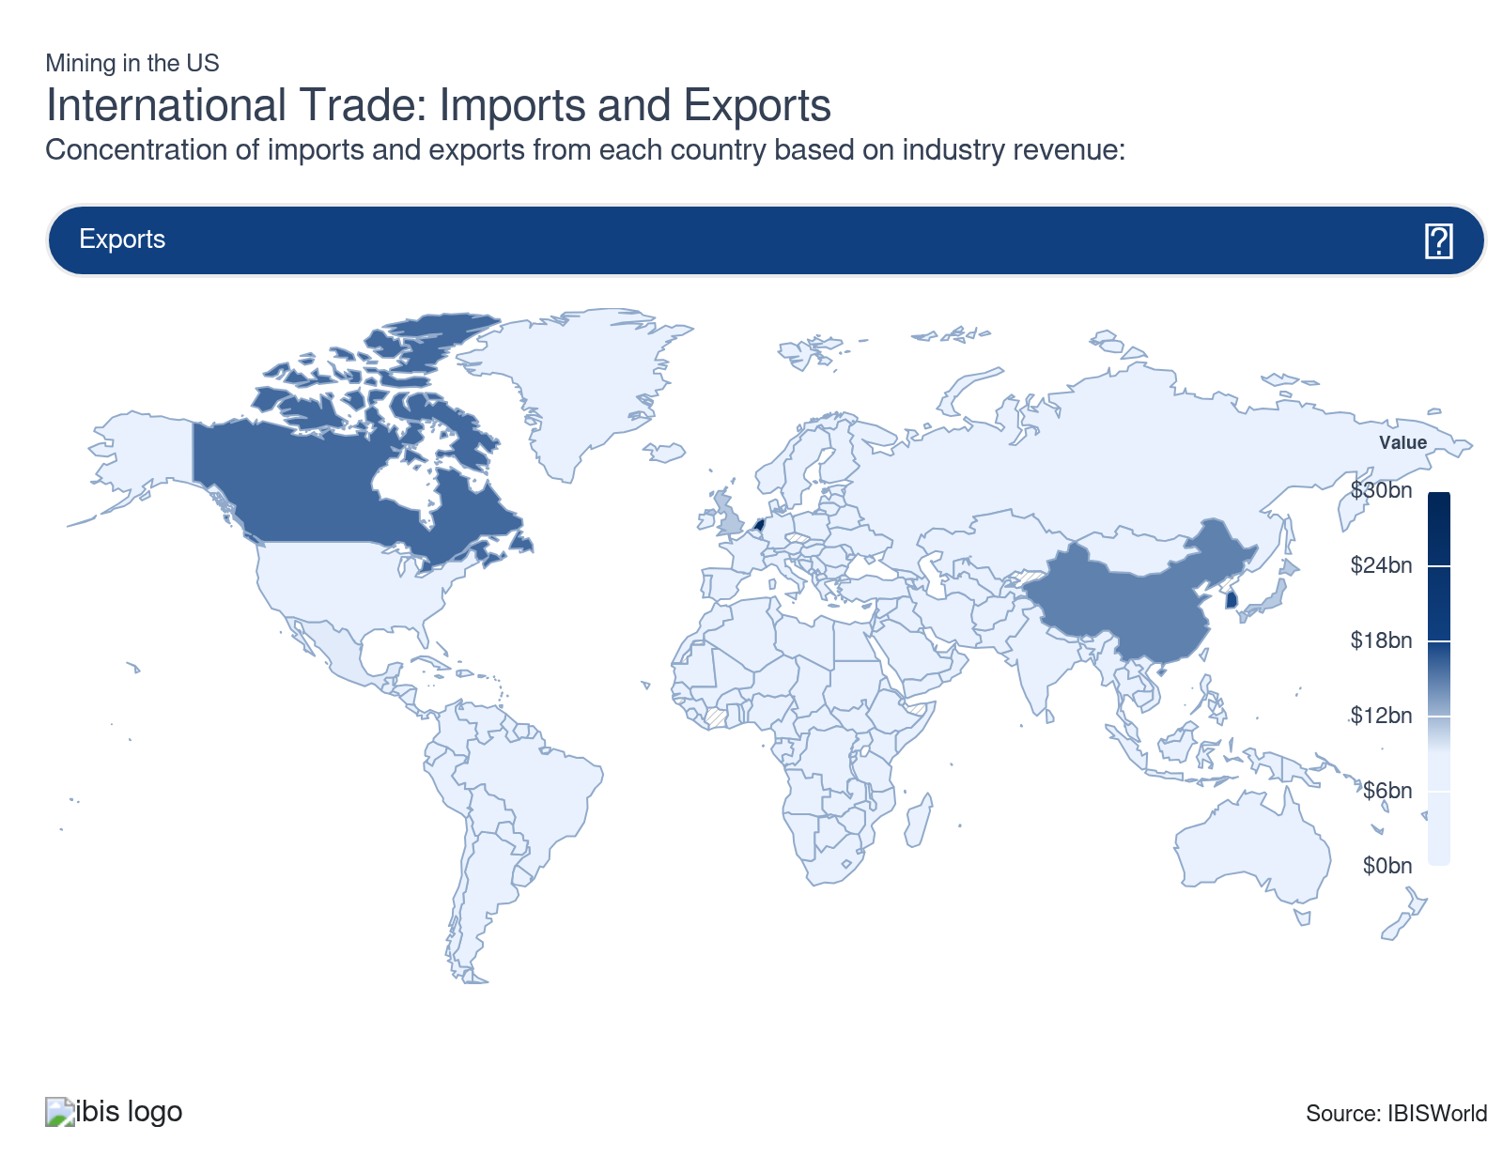

Imports
Moderate | Decreasing

What are the industry’s import trends?

Recent tariffs may impact future trade between Canada and Mexico
- Imports from Canada and Mexico have grown following the United States-Mexico-Canada Agreement (USMCA). They are the two most important international trading partners for the sector, with over two-thirds of all imports coming from those countries.
- Since Canada is rich in mineral resources, over 60.0% of sector imports are derived from there. The US imports a large amount of oil and gas, coal and iron ore from Canada. Oil and natural gas pipelines connect the US with Mexico and Canada, supporting trade between the two countries.
- Strong trade relations between these countries are essential, as many domestic companies maintain operations in Canada and Mexico. Nonetheless, with the Trump Administration implementing various tariffs on energy, metals and minerals, prices for these commodities may temporarily climb, as domestic production isn't enough to meet domestic demand for most of them. Currently, imports account for 25.1% of domestic demand. Even so, in late 2025, the US Department of the Interior added 10 new minerals to the Critical Minerals list. This may help production through 2031, reducing the need for these goods from overseas markets.

Oil and gas fuels sector imports
- Saudi Arabia and Colombia are significant sources of imports for the sector. Both countries are leading global energy producers and Saudi Arabia has continued to amass assets in the US liquid and gas industry.
- Imports from Saudi Arabia and Columbia have come to satisfy a smaller share of domestic demand in recent years. This is because of Mexico and Canada's surge in imports. They also have an advantage compared to Saudi Arabia and Columbia since they’re more conveniently located for inexpensive transportation costs. Nonetheless, the US may expand their reliance on these countries in the near future if tariffs on energy make Canadian and Mexican oil and gas more pricey.
- Although the US heavily relies on oil and gas imports, the Trump administration has expressed a desire to expand domestic production to reduce this dependency and lower prices for consumers. Currently, the reopening of Alaska's National Petroleum Reserve for leasing and development is the only policy in effect. However, if more policies are introduced in the future, we may see an increase in production as imports decrease.

Exports
High | Increasing

What are the industry’s export trends?

Exports skyrocket amid geopolitical tensions
- Russia's invasion of Ukraine led the United States and the European Union (EU) to impose sanctions on the country. Countries that have imposed sanctions on Russia have been looking to other countries to satisfy their energy needs. After the conflict, the Netherlands continued to rely on the US for natural gas, causing the US to surge and become the largest exporter of natural gas in 2024 and 2025.
- While the value of exports are set to drop through 2031, primarily because of a fall in commodity prices, export volumes will remain elevated as the need for natural gas remains strong overseas. The European Union will likely amp up their reliance on domestic liquified natural gas as they were unable to renew transportation contracts with Russia, since the pipelines run through Ukraine.
- The United States is also set to nearly double its production capacity by 2029, allowing companies to import larger volumes of LNG.

Other commodities are only a small portion of international trade
- Over three-quarters of exports are for crude oil and natural gas, with coal in second place. As natural gas continued to gain traction, many coal miners have turned toward export markets to generate revenue.
- China is a major coal importer, making it one of the premier destination, as coal still accounted for nearly 60.0% of electricity generation in 2023, according to China Electricity Council, a government-backed industrial association. The country is a major steel producer, bolstering the need for coal. Nonetheless, coal exports to China is in jeopardy because of a 15.0% retaliation tariff on domestic coal. Coal miners will look to stray away from China and focus on India as a major trade partner since it is the second-largest coal importer in the world.
- Metallic and nonmetallic mineral exports account for a small portion of revenue. These minerals are more challenging to transport, leading to higher expenses for buyers abroad. Even so, some minerals, like molybdenum and platinum, are not found in other countries, so they rely on the US for these resources.

5. Geographic Breakdown
https://my.ibisworld.com/us/en/industry/21/geographic-breakdown

Key Takeaways
- Miners must be located near natural resources. Nearly half of miners are in the Southwest, which holds significant oil and natural gas reserves and is a strategic hub for the sector.
- Companies involved in international trade often set up near ports or trade routes to cut transportation costs. This strategic positioning decreases expenses and boosts profitability, making it a common practice for maximizing financial efficiency.

Business Locations
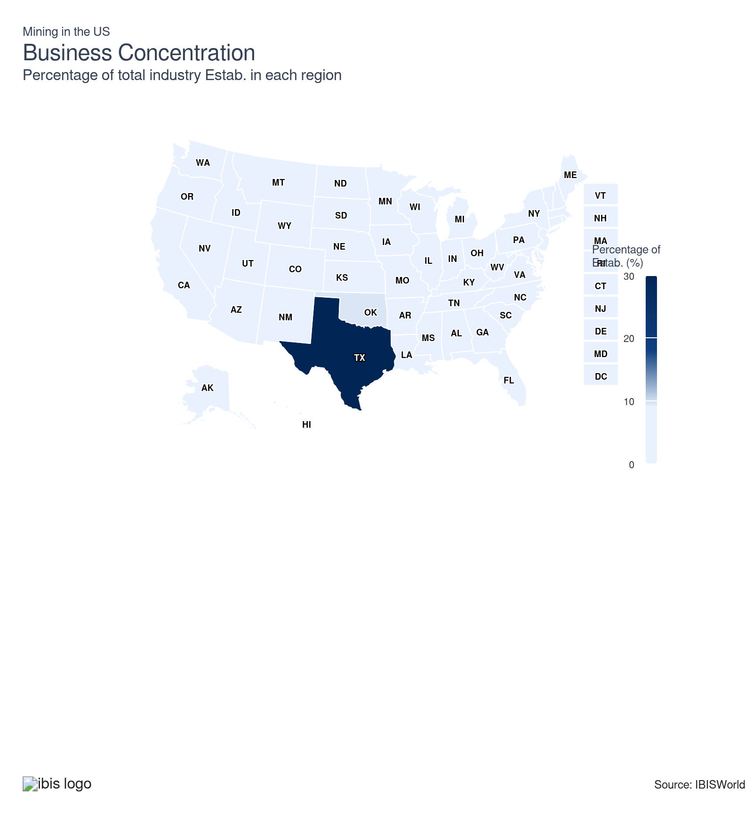
State | Estab.  Units | Estab.  % | Population  %
Texas | 7050 | 8.6 | 9.4
Oklahoma | 2232 | 2.7 | 1.2
Louisiana | 1218 | 1.5 | 1.3
Colorado | 946 | 1.2 | 1.8
Pennsylvania | 935 | 1.1 | 3.8
Kansas | 807 | 1.0 | 0.9
California | 651 | 0.8 | 11.5
New Mexico | 618 | 0.8 | 0.6
Ohio | 609 | 0.7 | 3.5
Wyoming | 578 | 0.7 | 0.2
North Dakota | 522 | 0.6 | 0.2
West Virginia | 467 | 0.6 | 0.5
Illinois | 436 | 0.5 | 3.7
Utah | 404 | 0.5 | 1.0
Michigan | 321 | 0.4 | 3.0
Montana | 324 | 0.4 | 0.3
Kentucky | 291 | 0.4 | 1.3
Arkansas | 270 | 0.3 | 0.9
New York | 279 | 0.3 | 5.8
Indiana | 258 | 0.3 | 2.0
Mississippi | 261 | 0.3 | 0.9
Missouri | 253 | 0.3 | 1.8
Arizona | 227 | 0.3 | 2.2
Florida | 227 | 0.3 | 7.0
Virginia | 236 | 0.3 | 2.6
North Carolina | 198 | 0.2 | 3.3
Georgia | 181 | 0.2 | 3.3
Iowa | 185 | 0.2 | 0.9
Nevada | 197 | 0.2 | 1.0
Tennessee | 180 | 0.2 | 2.1
Washington | 177 | 0.2 | 2.3
Alabama | 197 | 0.2 | 1.5
Alaska | 165 | 0.2 | 0.2
Minnesota | 166 | 0.2 | 1.7
Wisconsin | 154 | 0.2 | 1.7
Oregon | 131 | 0.2 | 1.2
Idaho | 125 | 0.2 | 0.6
Nebraska | 115 | 0.1 | 0.6
Massachusetts | 83 | 0.1 | 2.1
South Carolina | 96 | 0.1 | 1.6
Connecticut | 65 | 0.1 | 1.1
New Jersey | 76 | 0.1 | 2.8
South Dakota | 68 | 0.1 | 0.3
Maryland | 55 | 0.1 | 1.8
Vermont | 47 | 0.1 | 0.2
Delaware | 21 | 0.0 | 0.3
Maine | 25 | 0.0 | 0.4
New Hampshire | 30 | 0.0 | 0.4
Rhode Island | 13 | 0.0 | 0.3
District of Columbia | 0 | 0.0 | 0.2
Hawaii | 9 | 0.0 | 0.4

Where are industry businesses located?

Oil and gas production fuels the Southwest
- Texas accounts for nearly half of US crude oil production and almost a quarter of marketed natural gas production. Oklahoma also holds various reserves, making it a prime location for oil and gas companies. Because of this, these two states account for exactly 40.0% of all establishments in this sector.
- Unlike more densely populated or ecologically sensitive areas, the arid climate and expansive land area provide ideal conditions for large-scale mining and extraction activities without major environmental disruptions. The region's close proximity to Mexico allows companies to boost their revenue by expanding beyond domestic sales. The Gulf of Mexico, rich in oil and gas reserves, attracts producers areas where they can conduct offshore drilling.

The wide variety of resources in the Southeast justifies its high concentration
- Miners in the Southeast region mainly mine commodities like nonmetallic minerals and coal. Offshore drilling is prevalent because of the region's proximity to the Atlantic Ocean and the Gulf of Mexico. As a result the region hosts 16.5% of the sectors establishments, making it the second-largest in the country.
- Louisiana is home to many miners because of its rich stone, sand, gravel, oil and gas deposits, making it the state with the third-most amount of establishments. The region's proximity to major transportation networks like railroads and ports facilitates the efficient distribution of mined materials to other regions and export markets. According to the Louisiana Economic Development, the Louisiana Offshore Oil Port (LOOP) handles 13% of the nation’s foreign oil and connects by pipeline to 50% of the nation’s refining capability.

The Rocky Mountains and Plains regions mine for similar resources
- The Rocky Mountains and Plains are rich in valuable metallic and nonmetallic minerals, naturally attracting many miners. Both regions have favorable geographic terrains that facilitate operations. As a result, the region accounts for 10.3% and 9.1% of all sector establishments, respectively, making it the third and fourth largest in the sector.
- All iron ore mining operations in the region are situated in Minnesota and Michigan. The Minntac, Hibbing Taconite, Northshore and Keetac mines are all in Minnesota and contribute to most iron ore production in the country. Colorado and Idaho, rich in gold and silver deposits, are prime locations for miners. Additionally, Colorado boasts numerous oil and gas reserves along its mountain ranges and ranks fourth in sector establishments.
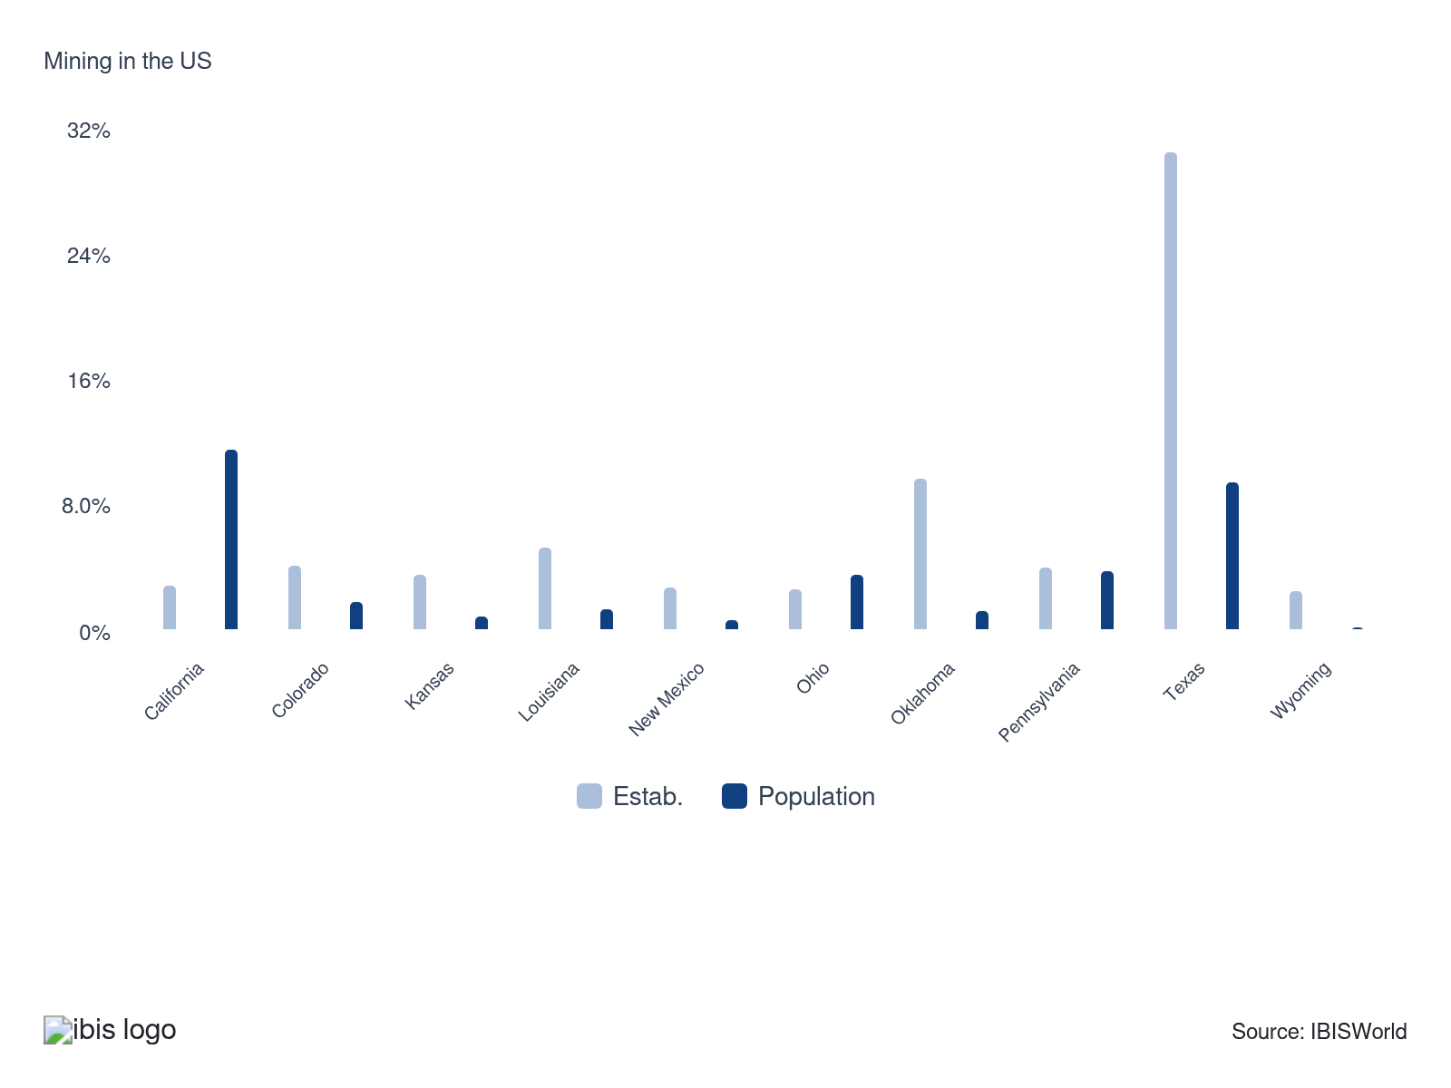

How do businesses use location to their advantage?
Proximity to key markets
Proximity to key markets allows mining companies to cut transportation costs and enhance profitability. This strategic advantage reduces expenses and boosts profit, making mining more efficient and financially viable.
Secure export markets
Oil, gas and mining companies exporting products prefer to be close to trade routes or ports. This ensures timely deliveries, enhancing operational efficiency and competitiveness in global markets. Logistics advantages are crucial for maintaining consistent supply chains.

6. Competitive Forces
https://my.ibisworld.com/us/en/industry/21/competitive-forces

Key Takeaways
- Miners compete mainly on price. The quality and purity of products also significantly affect competition. The top companies usually have the best access to rich deposits and reserves, making it harder for smaller entrants to compete.
- Mining, drilling and extracting are capital-intensive and heavily dependent on expensive heavy machinery. This ongoing financial burden can deter new companies from entering the sector.

Concentration
Low
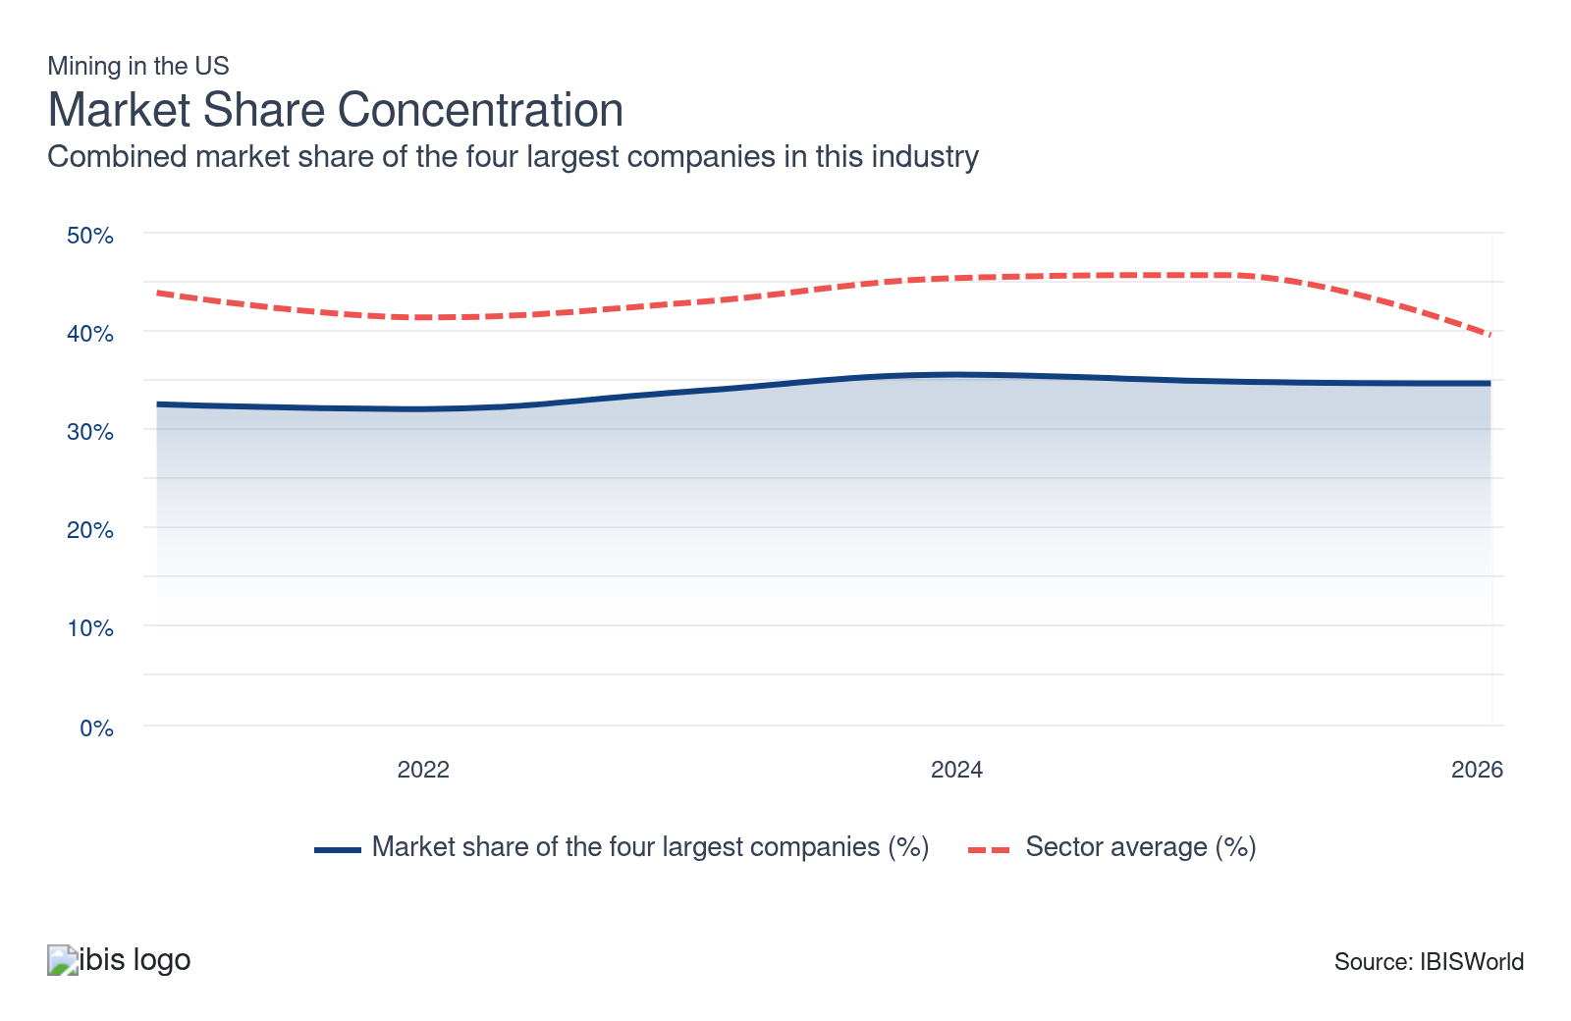

What impacts the industry’s market share concentration?

The fragmented nature of the oil and gas industry
- Companies with the largest market share concentration are in the oil and gas extraction or oil and gas field services industries. While oil drilling and gas extraction companies account for over three-quarters of total sector revenue, market share concentration remains low.
- Market share concentration is low because it’s difficult for even the most prominent companies to control more than a small share of output because of the industry's large size and dispersion across the nation. Most companies typically stick to a particular region.

Various types of companies exist in the sector
- Many oil and gas extractors are nonemployers without paid employees and rely significantly on automation and contractors. Even so, many smaller companies that can't absorb additional costs from price shifts or rising interest rates are at risk of consolidation.
- Many large mineral mining companies have a large hold on their industries, with access to high-grade deposits. This discourages new entrants since the minerals they mine are less valuable. Even so, with new minerals being added to the critical minerals list in 2025, more mining companies may pop up to help the US improve their supply chains.

How do successful businesses handle concentration?
Qualified work force
Although labor inputs are not large for the mining industry relative to revenue, appropriately trained and qualified employees are needed to ensure productivity. Skilled workers can handle advanced machinery and complex processes, driving productivity and ensuring compliance with stringent regulations.
Develop strong working relationships with subcontractors
Reliable subcontractors ensure timely project completion and maintain high-quality standards, which are essential for success and stability in the mining industry.

Barriers to Entry
High | Steady

What challenges do potential industry entrants face?

Legal
- Stringent regulations and environmental laws serve as gatekeepers, making legal compliance challenging for new entrants. Failure to comply can lead to fines or mine closures. Noncompliance can also damage a company’s reputation and undermine its ability to secure permits or community support for future projects.

Start-up Costs
- Initial investment requires machinery, land acquisition and exploration to establish a competitive mine. These sky-high start-up costs can drain even the deepest pockets, deterring many hopeful miners. Securing financing for capital-intensive projects often demands long lead times, detailed feasibility studies and significant collateral, which many smaller miners simply cannot provide.

Differentiation
- Long-term contracts between existing miners and buyers (both local and overseas) can also pose a substantial barrier to entry since new miners may find it difficult to secure new contracts. It's also hard for new mining companies to find solid deposits.

Labor Expenses
- While labor represents an integral input of sector activities, companies chiefly rely on large-scale capital equipment for their output.

Capital Expenses
- Mining companies rely mainly on large-scale heavy equipment, making it a capital-intensive industry despite the industry's reliance on labor. These ongoing expenses can pose an issue for new entrants. Miners must also replace equipment very frequently, which keeps costs elevated.

How can potential entrants overcome barriers to entry?
Ability to accommodate environmental requirements
Stricter environmental regulations require businesses to prioritize sustainability. To comply with these measures, companies must adapt to more stringent standards. The focus on environmental protection has become essential for miners.
Ability to find new resource deposits
Mining companies' growth hinges on discovering and developing new resource deposits. Large companies already control many high-grade deposits, making it more challenging for newcomers.

Substitutes
Low | Steady

What are substitutes for industry services?

Imports
- New international mineral reserves consistently challenge domestic miners. Extracting newly discovered resources abroad can weaken export performance and bolster the pressure from imported minerals.
- The appreciation of the US dollar has contributed to a drop in the cost of foreign commodities for domestic downstream markets. This trend has enhanced the penetration of imports in the local market, creating additional competitive pressures for domestic producers.
- The new minerals added to the critical minerals list will allow domestic miners to improve their supply chains and reduce their reliance on imports moving forward.

Solar Power
- Solar power and other forms of renewable energy are a substitute for domestic miners. Renewable energy will increasingly replace coal, oil and natural gas as the US continues to invest in renewable energy infrastructure.
- Initiatives like the Inflation Reduction Act underscore the government's commitment to renewable energy. This legislative effort provides various tax incentives to homeowners and businesses transitioning to renewable energy sources. Even so, the One Big Beautiful Bill Act cut residential tax credits at the end of 2025 and will eliminate production tax credits by 2027, so this looming competition is set to be minimized.

How do successful businesses compete with substitutes?
Invest in research and development
Constant innovation in mining techniques and processes helps the US mining industry stay ahead of potential substitutes by enhancing extraction efficiency, bolstering sustainability and reducing costs.
Offer a competitively priced product
Keeping commodities competitively priced helps miners maintain their market position by making it less attractive for consumers to switch to substitute materials. Price competitiveness can directly deter potential competitors.

Buyer & Supplier Power
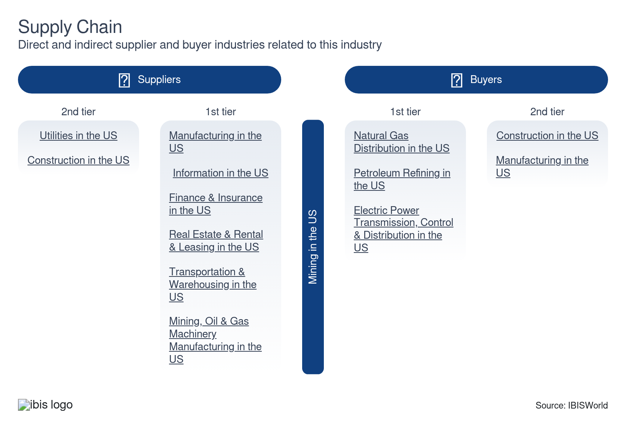

What power do buyers and suppliers have over the industry?

Buyers: Contracts can reduce costs
Moderate | Steady
- Manufacturers can enhance their buying power by securing contracts with oil and gas companies and mining firms. This approach helps mitigate the impact of price volatility and inflation, which heavily affects operational costs.
- Construction companies often face challenges with buying power because of the unpredictable nature of their material needs. Since they typically don't know the specific materials required until a project is undertaken, their purchasing processes tend to be less stable and more reactive.

Suppliers: Input costs are key
High | Steady
- It's important for miners to have contracts with oil suppliers. Rising oil prices will hammer miners who don't have established contracts as it becomes more costly to operate their heavy machinery (rigs, excavators, pumps and bulldozers).
- Heavy machinery manufacturers hold considerable power in this context, often charging a premium for their products when steel prices push up. This dynamic underscores the need for miners to manage their supply chains effectively to mitigate the impact of fluctuating input costs. Companies will enter long-term partnerships to avoid volatility costs and keep depreciation costs steady.

How do successful businesses manage buyer & supplier power?
Downstream ownership links
Owning downstream operations can ensure a steady flow of revenue from mined products, enhance control over the supply chain and reduce buyers' bargaining power.
Economies of scale
Achieving economies of scale lowers production costs per unit, boosting competitive pricing and profitability. This diminishes buyer power by offering better value and strengthens negotiating positions with suppliers because of higher purchase volumes.

7. Companies
https://my.ibisworld.com/us/en/industry/21/companies

Key Takeaways
- The largest companies in the sector focus on oil and gas since it generates the largest portion of revenue. Even so, it’s difficult for these companies to control more than a modest share of output.
- With swelling energy prices, Exxon Mobil has announced it will bolster its gasoline and diesel production at its Beaumont refinery. This will help keep supply and prices steady amid volatile conditions.

Market Share
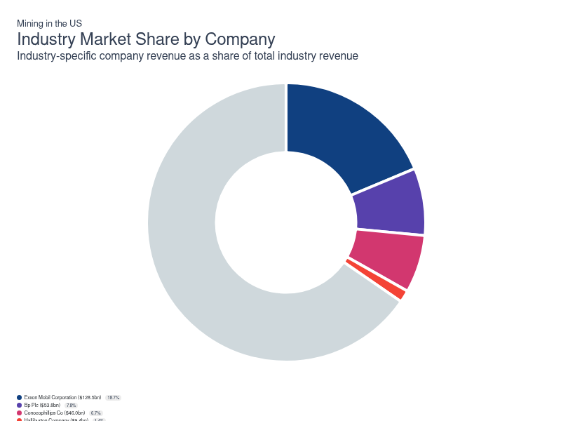
Chart displays current year only in the PDF version of this report. You can view and download chart for all other years associated with this industry on my.ibisworld.com.

Companies
Company | Market Share (%)  2026 | Revenue ($m)  2026 | Profit ($m)  2026 | Profit Margin (%)  2026
Exxon Mobil Corporation | 18.7 | 128,529.5 | 17,206.8 | 13.4
Bp Plc | 7.8 | 53,790.0 | 3,782.8 | 7.0
Conocophillips Co | 6.7 | 45,983.7 | 8,939.6 | 19.4
Halliburton Company | 1.4 | 9,379.2 | 674.3 | 7.2
Vulcan Materials Company | 1.2 | 8,338.0 | 1,187.6 | 14.2
Freeport-Mcmoran Inc. | 1.2 | 8,082.2 | 2,576.7 | 31.9

Exxon Mobil Corporation
Exxon Mobil Corporation
Company Details
Company Details
Industry Specific Revenue (2026) | $128.5bn
Industry Profit (2026) | $17.2bn
Company Employees (2026) | 60,900
Market Share (2026) | 18.7%

Description
Description
Exxon Mobil is a public company headquartered in Texas with an estimated 60,900 employees. In the US, the company has a notable market share in at least five industries: Mining, Oil & Gas Extraction, Petroleum Refining, Lubricant & Other Petroleum Product Manufacturing, Gasoline & Petroleum Bulk Stations and Gasoline & Petroleum Bulk Stations. Their largest market share is in the Lubricant & Other Petroleum Product Manufacturing industry, where they account for an estimated 19.7% of total industry revenue.

Brands and Trading Names
Brands and Trading Names
- Mobil
- Mobil 1

Other Industries
Other Industries
- Gasoline & Petroleum Bulk Stations in the US
- Lubricant & Other Petroleum Product Manufacturing in the US
- Oil & Gas Extraction in the US
- Petroleum Refining in the US

Company’s Industry Revenue, Market Share, and Profit Margin Over Time
Company’s Industry Revenue, Market Share, and Profit Margin Over Time
Year | Industry Revenue ($ million) | Market Share (%) | Profit Margin (%)
2021 | 104236 | 16.9 | 11.3
2022 | 149225 | 16.5 | 19.5
2023 | 127374 | 17.7 | 15.8
2024 | 138657 | 19.7 | 14.4
2025 | 133941 | 18.8 | 13.3
2026 | 128529 | 18.7 | 13.4

What's impacting Exxon Mobil Corporation's performance?

Exxon Mobil sues the EU over windfall tax
- Following Brussel's decision to impose a new windfall tax on oil companies, Exxon Mobil has sued the European Union (EU), arguing that it does not have the authority to impose the levy. Announced in December of 2022, the lawsuit comes as energy prices throughout the west continue to rise as a result of the Russian-Ukaraine war.

Hedge fund installs three new directors on the board of ExxonMobil
- Since being established in late 2020, US hedge fund Engine No. 1 sought to bring value-creating, transformational change through active ownership. One of the investment fund’s key accomplishments was gaining shareholder support to instill three, environmentally-focused directors to the board of directors of Exxon Mobil Corporation (ExxonMobil) in 2021. Despite Engine No. 1’s minimal direct ownership of ExxonMobil shares, the hedge fund received support from important shareholders such as BlackRock, Vanguard and State Street for its strategy to succeed. Dubbed Reenergize Exxon, the campaign plans to pivot ExxonMobil to be an important driver of the global energy transition.

ExxonMobil accelerates production in Texas
- As energy prices continue to rise, Exxon Mobil has announced that it has boosted gasoline and diesel production at its refinery in Beaumont, Texas. Valued at $2.0 billion, the expansion will help to keep energy supply and prices steady throughout the world.

ExxonMobil continues to expand with latest acquisition
- In May 2024, ExxonMobil announced it had completed its acquisition of Pioneer Natural Resources Company, a significant hydrocarbon explorer in the Permian Basin. This acquisition more than doubles ExxonMobil's stake in the Permian Basin. It is set to more than double the company's daily production and help accelerate its net zero 2050 plan to 2035.

Project and portfolio management
- ExxonMobil has bought and sold numerous assets over the past decade in a bid to improve the company’s overall long-term strategic value. For example, the company acquired Nobel-prize winning technology developer, Materia Inc. (Materia) in 2021. Materia produces hydrocarbon-based materials that can be used in numerous applications, including wind turbine blades, electric vehicle parts and sustainable construction. ExxonMobil has also divested of significant assets, including $4.5 billion of non-operating assets in Norway. The company has plans to divest $25.0 billion of other hydrocarbon assets over the next several years based upon the understanding that they are no longer meeting the company’s strategic objective.
Bp Plc
Bp Plc
Company Details
Company Details
Industry Specific Revenue (2026) | $53.8bn
Industry Profit (2026) | $3.8bn
Company Employees (2026) | 100,500
Market Share (2026) | 7.8%

Description
Description
Bp is a public company headquartered in United Kingdom with an estimated 100,500 employees. In the US, the company has a notable market share in at least seven industries: Mining, Oil & Gas Extraction, Petroleum Refining, Lubricant & Other Petroleum Product Manufacturing, Gasoline & Petroleum Wholesaling, Gas Stations, Oil Pipeline Transportation and Oil Pipeline Transportation. Their largest market share is in the Gas Stations industry, where they account for an estimated 8.7% of total industry revenue.

Brands and Trading Names
Brands and Trading Names
- AMOCO
- Ampm
- ARAL
- Arco
- Blueprint Power
- BP
- Castrol
- Chargemaster
- Finite Carbon
- IVESCO
- MWI Veterinary Supply
- Open Energi
- Wild Bean Café

Other Industries
Other Industries
- Gas Stations in the US
- Gasoline & Petroleum Wholesaling in the US
- Lubricant & Other Petroleum Product Manufacturing in the US
- Oil & Gas Extraction in the US
- Oil Pipeline Transportation in the US
- Petroleum Refining in the US

Company’s Industry Revenue, Market Share, and Profit Margin Over Time
Company’s Industry Revenue, Market Share, and Profit Margin Over Time
Year | Industry Revenue ($ million) | Market Share (%) | Profit Margin (%)
2020 | 27413 | 6.6 | -20.5
2021 | 53748 | 8.7 | 11.5
2022 | 71118 | 7.9 | 7.5
2023 | 60577 | 8.4 | 13.0
2024 | 58804 | 8.3 | 6.0
2025 | 56051 | 7.9 | 6.9
2026 | 53790 | 7.8 | 7.0

What's impacting Bp Plc's performance?

BP entered the US offshore wind market in 2021
- In 2021, BP and Equinor ASA completed the formation of a strategic offshore wind partnership off the US East Coast. The two companies were selected for the largest-ever US offshore wind award for their Empire Wind and Beacon Wind projects, which are expected to supply New York State with 3.3 gigawatts (GW) of power. The new partnership is estimated to develop up to 4.4 GW through the two projects, and the companies are jointly seeking other offshore wind opportunities. BP aims to grow its net renewable generating capacity from 2.5 GW in 2019 to 50 GW by 2030.

BP exits stake with Russian energy company amid global tensions
- On February 27, 2022, BP PLC (BP) exited its 19.75% shareholding in PJSC Rosneft Oil Company (Rosneft), which has been involved since 2013. Rosneft is Russia’s state-owned integrated oil company, which has recently drawn flak amid Russia’s decision to invade Ukraine. World governments and global enterprises have recently enacted financial controls to hit Russia’s financial, energy and transportation sectors, including BP’s recent decision to cut ties with the energy giant. BP-nominated directors currently serving on the Rosneft board have also resigned immediately.

Stage 1 of Herschel Expansion project completed in the Gulf of Mexico
- In February 2022, BP announced its Herschel expansion project's safe and successful start-up in the Gulf of Mexico. The new project utilizes existing infrastructure to maximize value in the Na Kika Catchment Area. Phase 1 of the project encompasses developing new subsea production systems and the first of up to three wells tied to the Na Kika platform. At its peak, BP estimates the first well to increase peak annual average production by 15 MBOE/d. BP and Royal Dutch Shell PLC each hold a 50.0% working interest in the development.
Conocophillips Co
Conocophillips Co
Company Details
Company Details
Industry Specific Revenue (2026) | $46.0bn
Industry Profit (2026) | $8.9bn
Company Employees (2026) | 9,500
Market Share (2026) | 6.7%

Description
Description
Conocophillips Co is a public company headquartered in Texas with an estimated 9,500 employees. In the US, the company has a notable market share in at least two industries: Mining, Oil & Gas Extraction and Oil & Gas Extraction. Their largest market share is in the Oil & Gas Extraction industry, where they account for an estimated 8.0% of total industry revenue.

Brands and Trading Names
Brands and Trading Names
- Conoco

Other Industries
Other Industries
- Oil & Gas Extraction in the US

Company’s Industry Revenue, Market Share, and Profit Margin Over Time
Company’s Industry Revenue, Market Share, and Profit Margin Over Time
Year | Industry Revenue ($ million) | Market Share (%) | Profit Margin (%)
2019 | 20997 | 3.6 | 26.0
2021 | 34786 | 5.6 | 26.3
2022 | 60826 | 6.7 | 34.4
2023 | 45342 | 6.3 | 27.8
2024 | 43480 | 6.2 | 24.0
2025 | 48291 | 6.8 | 20.2
2026 | 45984 | 6.7 | 19.4

What's impacting Conocophillips Co's performance?

Increasingly stringent federal regulations delay new oil projects
- Oil and gas producers have come under increasing scrutiny from environmental laws and regulations seeking to protect the environment. Most recently, US federal judges invalidated the permit for ConocoPhillips’ Willow oil projects on Alaska’s North Slope based on newfound environmental concerns. The organization is slated to invest $6.0 billion in capital to the Willow project which is projected to produce more than 160,000 barrels of oil per day. New laws, regulations and permitting requirements could likely impose additional costs, restrictions, operational delays and ultimately limit resource development which could materially affect the company as an ongoing concern.

Soaring oil prices bode well for producers
- The world price of oil has surged tremendously since the outset of the COVID-19 pandemic on account of supply shortages and recent geopolitical conflicts. Specifically, production was slashed during the global health crisis as demand floundered. However, the recent retracement of global stay-at-home orders has led to a significant increase in hydrocarbon demand without a similar increase in supply, pressuring prices higher. Furthermore, the Biden Administration recently announced an oil embargo against Russia amid its attack on Ukraine, raising prices further by taking the supply from a leading oil producing nation off the market.

ConocoPhillips continues to expand its domestic presence
- In May 2024, ConocoPhillips announced it would acquire Marathon Oil for $22.5 billion. The deal will expand the company's domestic footprint and help reduce operational costs. The company projects $500 million in savings within the first year from improved capital efficiencies and reduced operating costs. The deal is set to close in the fourth quarter of 2024, pending approvals.

ConocoPhillips sues Alaskan governor's administration
- In early 2023, ConocoPhillips announced that it has sued Alaskan Gov. Mike Dunleavy's adminstation over a permit issued by the state which allows competition to access its North Slope development. The move comes following failed negotiations between Conoco and Australia-based Santos, which ultimately led to Santos earning a state permit against Conoco's wishes.
Halliburton Company
Halliburton Company
Company Details
Company Details
Industry Specific Revenue (2026) | $9.4bn
Industry Profit (2026) | $674.3m
Company Employees (2026) | 48,000
Market Share (2026) | 1.4%

Description
Description
Halliburton Company is a public company headquartered in Texas with an estimated 48,000 employees. In the US, the company has a notable market share in at least three industries: Mining, Oil & Gas Field Services, Mining, Oil & Gas Machinery Manufacturing and Mining. Their largest market share is in the Mining, Oil & Gas Machinery Manufacturing industry, where they account for an estimated 9.6% of total industry revenue.

Brands and Trading Names
Brands and Trading Names
- Baroid
- Landmark
- Sperry Drilling
- Summit ESP

Other Industries
Other Industries
- Mining, Oil & Gas Machinery Manufacturing in the US
- Oil & Gas Field Services in the US

Company’s Industry Revenue, Market Share, and Profit Margin Over Time
Company’s Industry Revenue, Market Share, and Profit Margin Over Time
Year | Industry Revenue ($ million) | Market Share (%) | Profit Margin (%)
2008 | 6037 | 1.1 | -21.5
2009 | 3839 | 1.0 | -21.5
2010 | 4767 | 1.1 | -21.5
2011 | 6274 | 1.2 | -21.5
2012 | 5915 | 1.1 | -21.5
2013 | 6562 | 1.1 | -21.5
2014 | 7331 | 1.1 | -21.5
2015 | 5347 | 1.2 | -21.5
2016 | 4567 | 1.2 | -21.5
2017 | 8166 | 1.8 | 9.8
2018 | 9238 | 1.6 | 10.3
2019 | 8739 | 1.5 | -2.0
2020 | 5489 | 1.3 | -16.9
2021 | 6118 | 1.0 | 11.8
2022 | 7967 | 0.9 | 6.4
2023 | 9379 | 1.3 | 7.2
2024 | 9379 | 1.3 | 7.2
2025 | 9379 | 1.3 | 7.2
2026 | 9379 | 1.4 | 7.2

What's impacting Halliburton Company's performance?

Automation activity continues to be in the works
- In November 2023, Halliburton announced its partnership with Sekal AS to develop advanced well construction automation solutions to enhance automation throughout drilling activities. This collaboration integrates Sekal's DrillTronics automation with Halliburton's tools, supporting various aspects of drilling, including planning and execution. The goal is to reduce costs and leverage automation to minimize workplace risks for workers.

Geopolitical instability and its effect on oil producers
- The world prices of oil and gas have been on the rise on account of current production being insufficient at matching the rapid increase in demand amid the global reopening. Simultaneously, several large oil-consuming countries, including the United States, have blocked purchases of Russian hydrocarbons due to ongoing conflict between Ukraine and Russia. The Russian oil embargo is expected to drive oil prices higher as the large hydrocarbon supplier is effectively taken off of the market. Oil and gas field service companies such as Halliburton Company (Halliburton) are slated to benefit as drilling activity rises and demand for hydrocarbon products and services heats up.
Vulcan Materials Company
Vulcan Materials Company
Company Details
Company Details
Industry Specific Revenue (2026) | $8.3bn
Industry Profit (2026) | $1.2bn
Company Employees (2026) | 10,382
Market Share (2026) | 1.2%

Description
Description
Vulcan Materials Company is a public company headquartered in Alabama with an estimated 10,382 employees. In the US, the company has a notable market share in at least four industries: Mining, Stone Mining, Sand & Gravel Mining, Asphalt Manufacturing and Mining. Their largest market share is in the Stone Mining industry, where they account for an estimated 20.0% of total industry revenue and are considered an All Star because they display stronger market share, profit and revenue growth compared to their peers.

Brands and Trading Names
Brands and Trading Names
- General Shale Brick
- General Shale Products Corporation
- Vulcan Classic
- Vulcan Completion Products
- Vulcan High Viz
- Vulcan Materials Company
- Vulcan Proseries
- Vulcan Silver

Other Industries
Other Industries
- Asphalt Manufacturing in the US
- Sand & Gravel Mining in the US
- Stone Mining in the US

Company’s Industry Revenue, Market Share, and Profit Margin Over Time
Company’s Industry Revenue, Market Share, and Profit Margin Over Time
Year | Industry Revenue ($ million) | Market Share (%) | Profit Margin (%)
2008 | 3622 | 0.6 | 18.5
2009 | 2304 | 0.6 | 18.5
2010 | 2860 | 0.7 | 18.5
2011 | 3765 | 0.7 | 18.5
2012 | 3549 | 0.6 | 18.5
2013 | 3938 | 0.6 | 18.5
2014 | 4399 | 0.6 | 18.5
2015 | 3209 | 0.7 | 18.5
2016 | 2741 | 0.7 | 18.5
2017 | 2904 | 0.6 | 16.4
2018 | 4372 | 0.7 | 17.1
2019 | 4915 | 0.9 | 17.8
2020 | 4846 | 1.2 | 18.4
2021 | 5532 | 0.9 | 18.2
2022 | 7835 | 0.9 | 12.2
2023 | 8338 | 1.2 | 14.2
2024 | 8338 | 1.2 | 14.2
2025 | 8338 | 1.2 | 14.2
2026 | 8338 | 1.2 | 14.2

You can view and download company details on my.ibisworld.com.

8. External Environment
https://my.ibisworld.com/us/en/industry/21/external-environment

Key Takeaways
- Sanctions were placed on Russian energy following its invasion of Ukraine. This bolstered the need for domestic oil and gas since countries previously dependent on Russian energy had to find a new source.
- Recent legislation has supported the sector during turbulent times. The latest infrastructure bill will ensure a steady need for stone, sand and gravel as contractors repair and construct roads and highways.
- In late 2025, the US Department of the Interior updated its critical mineral list, adding boron, copper, lead, metallurgical coal, phosphate, potash, rhenium, silicon, silver and uranium. These additions reflect growing concern about materials needed for clean energy technologies, fertilizers, advanced manufacturing and defense systems.

External Drivers

What demographic and macroeconomic factors impact the industry?
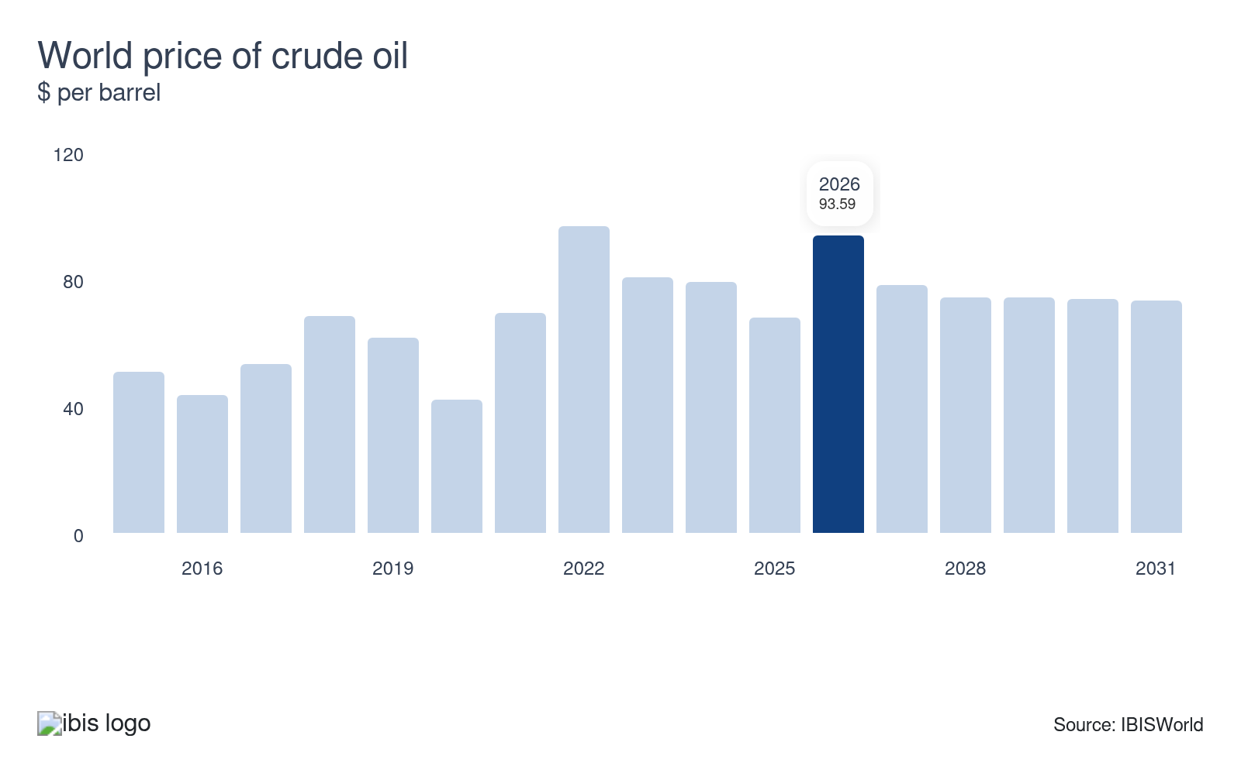
The oil industry's pricing is primarily governed by the fundamental principles of supply and demand, which leads to significant volatility in oil prices. Fluctuations in price can have profound effects on sector revenue and profit. When prices climb, opportunities for growth within the sector often emerge, as higher revenue can bolster investments and enhance operational capabilities.
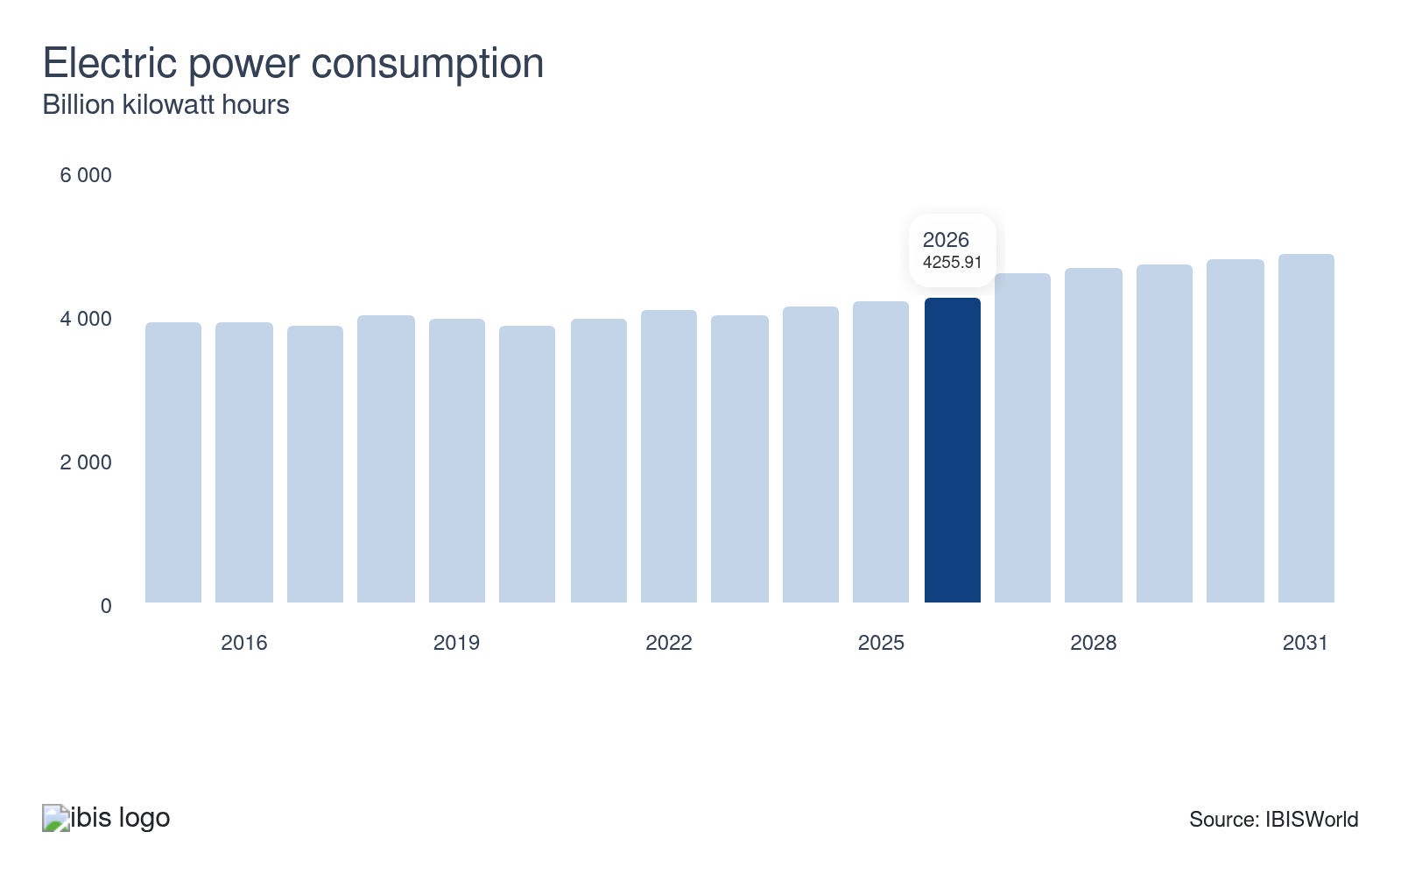
The need for coal in the US depends heavily on electricity demand, which is a key determinant of coal usage. More than half the coal produced in the US is consumed to produce electricity, so any upward trends in the electric power market positively affect companies in the mining sector.
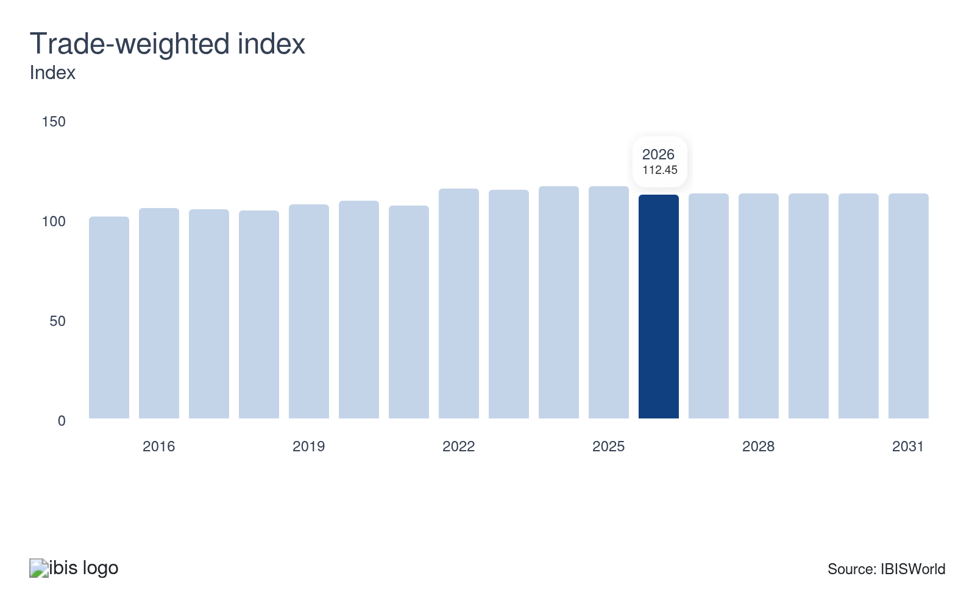
Mining has increasingly relied on energy exports as a source of demand in recent years. The trade-weighted index (TWI) represents the value of the US dollar relative to foreign currencies. When the TWI decreases, US products become less expensive on the global market. Even so, a rising TWI decreases the attractiveness of domestic products on the international market as the dollar appreciates, posing a potential threat to the sector.
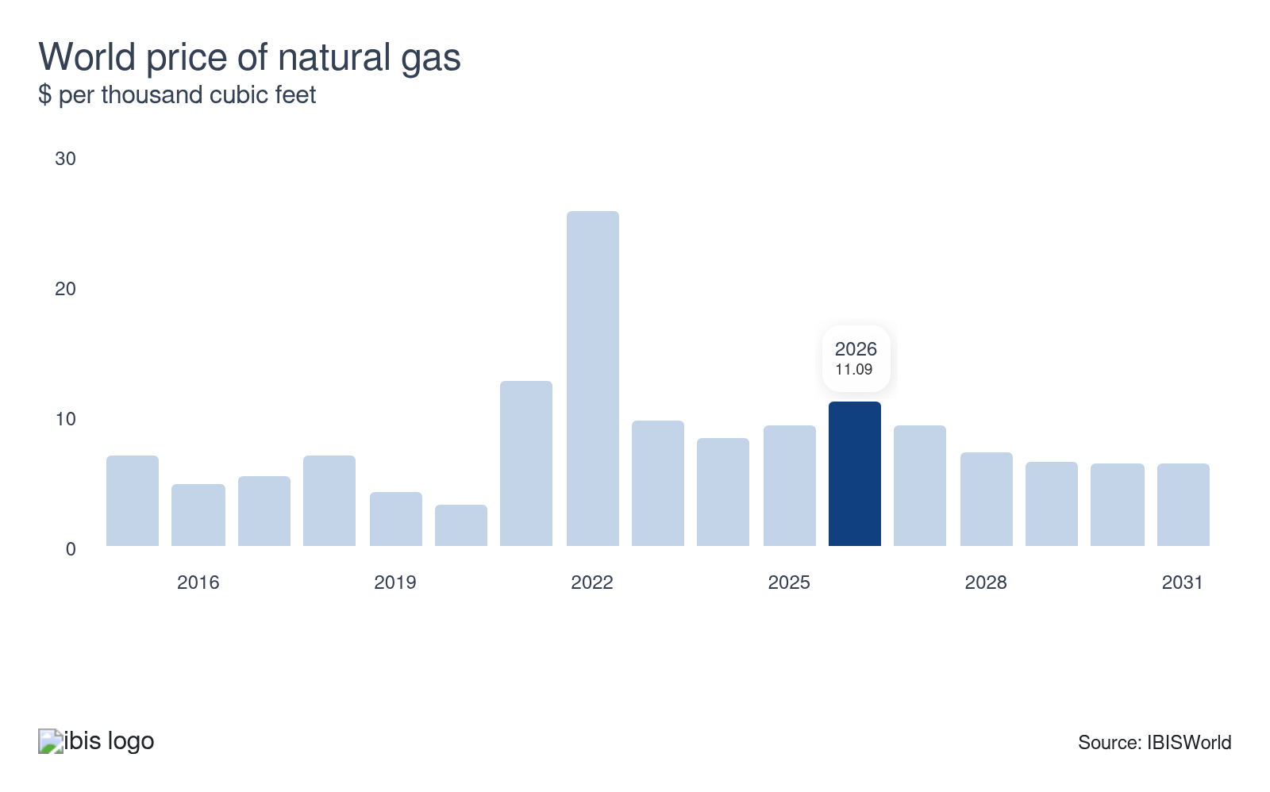
Natural gas prices are influenced by a complex interplay of international and local supply and demand trends, often resulting in significant volatility. Fluctuating prices directly impact revenue and production within the natural gas industry. When prices swell, companies typically enjoy an expansion in revenue, which can lead to more investment and exploration activities.
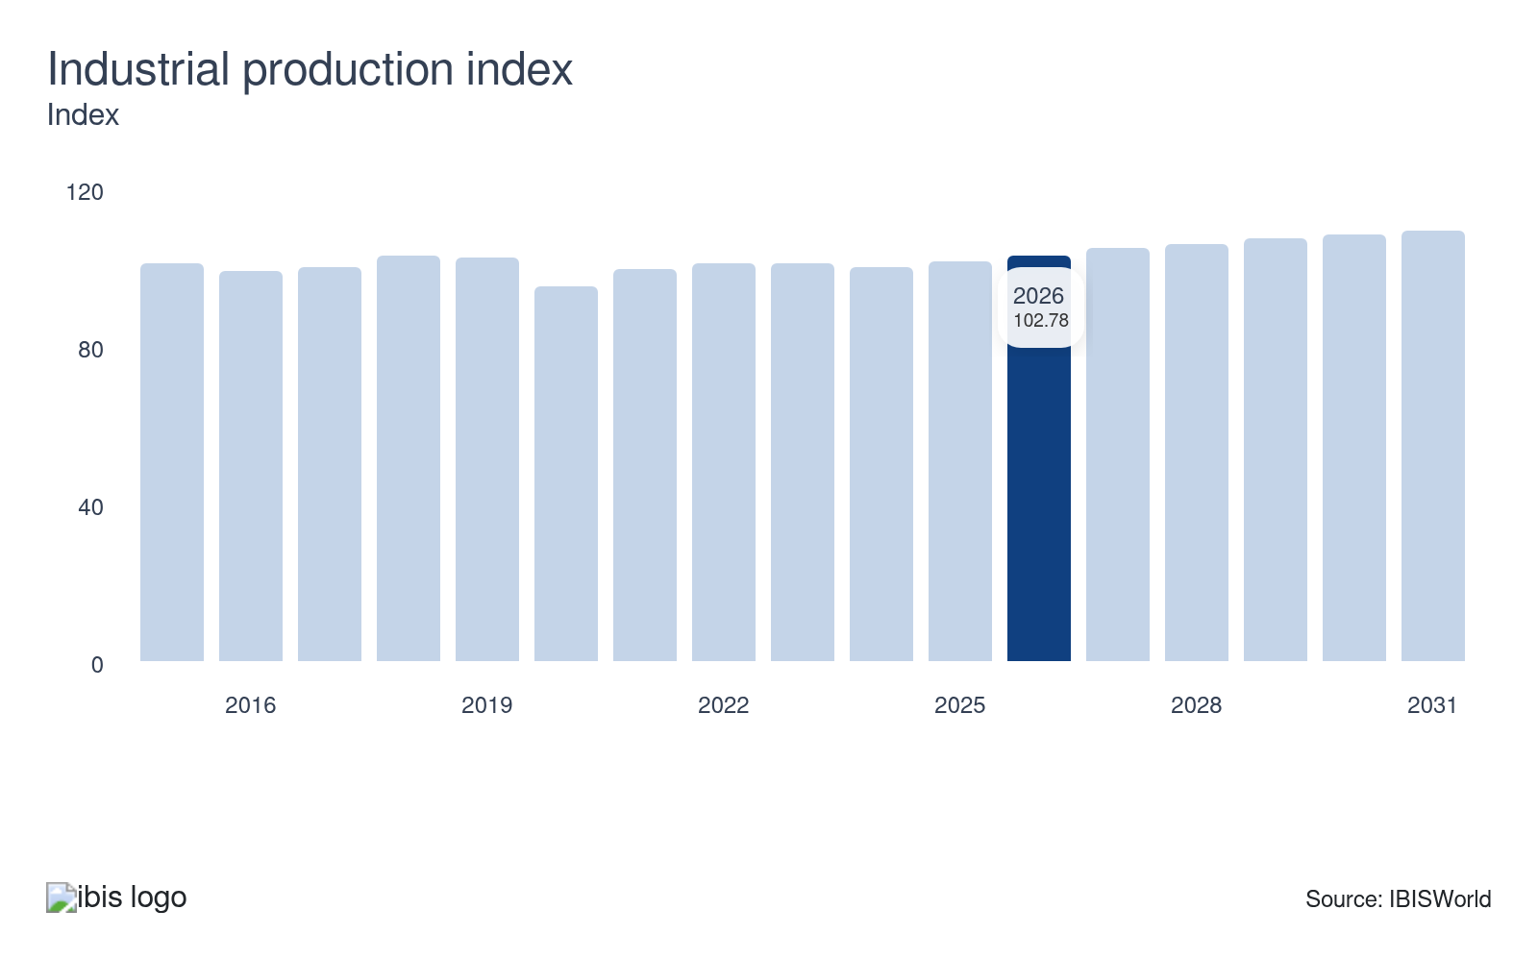
The industrial production index measures total production from the Manufacturing (IBISWorld report 31-33) and Mining and Utility sectors (22). Manufacturing and utility companies require raw materials from the Mining sector as feedstock for operations. Increasing levels of industrial production results in greater need for the Mining sector. In turn, industrial production growth boosts revenue for companies in this sector.
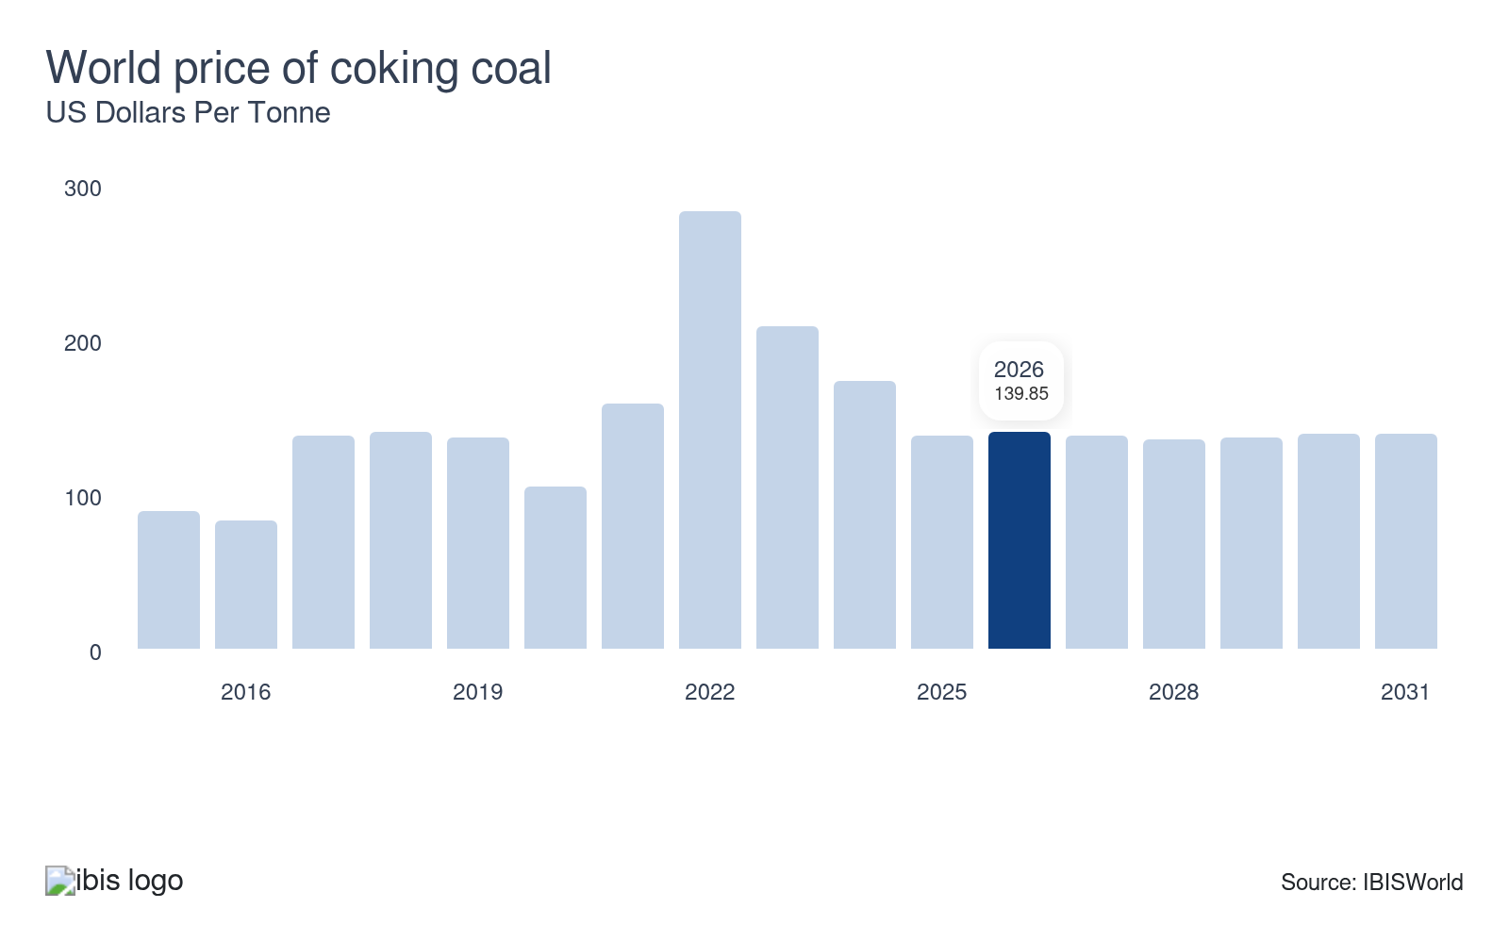
Coking coal, or metallurgical coal, is primarily pivotal in the coal industry because of its connection to steel production. As the need for steel swells, so does the need for coking coal, which often leads to increased coal prices. This price surge signals greater demand, typically resulting in higher revenues and profit for coal miners.

Regulation & Policy
High | Increasing

What regulations impact the industry?

The Surface Mining Control and Reclamation Act of 1977 (SMCRA)
The Surface Mining Control and Reclamation Act (SMCRA) of 1977 mandates strict environmental standards for surface and deep mining activities. Administered by the Office of Surface Mining Reclamation and Enforcement (OSMRE), mining operators must secure and renew SMCRA permits. States assume regulatory authority once they adopt federal programs. This regulation ensures mining practices meet environmental, air and water quality standards.

Operating and environmental regulations
SMCRA obliges compliance with major environmental laws like the Clean Air and Clean Water Acts. Miners face liability for hazardous spills under the Comprehensive Environmental Response, Compensation and Liability Act and the Oil Pollution Act of 1990. The Resource Conservation and Recovery Act allows the EPA to manage hazardous waste from creation to disposal, ensuring comprehensive environmental protection.

The Inflation Reduction Act
Signed into law in August 2022, the Inflation Reduction Act offers financial benefits to the mining sector. It allows mining companies to write off 10.0% of their operating costs if they produce "critical materials," which are substances necessary for technology and subject to supply risks. This encourages domestic production of essential materials, reducing dependency on foreign sources.

Sanctions on Russia
In response to the Russian invasion of Ukraine, President Joe Biden imposed bans on the imports of Russian oil, coal and liquified natural gas. Since Russia supplied 11.0% of the world's oil and 25.0% of Europe's, these sanctions significantly impact global oil supplies, particularly in Europe. This move aims to reduce Western reliance on Russian energy sources.

Occupational Safety and Health Administration (OSHA)
OSHA sets standards for worker safety in mining operations. This includes regulations on exposure to hazardous substances, machinery safety and workplace conditions. Mining companies must comply with these regulations to prevent accidents and protect worker health, maintaining a safe and secure working environment.

Assistance
Low | Steady

What assistance is available to this industry?

Taxes
Expensing intangible drilling costs enables companies engaged in domestic oil and gas production to treat costs like fuel, labor, supplies and repairs as expense items, an exception to general tax rules. Integrated oil companies can only expense 70.0% of these costs, while independent producers can fully expense these costs. Percentage depletion allowances permit independent producers to subtract 15.0% of sales from a productive well's property as a deduction.

Bipartisan Infrastructure Law
In November 2021, President Biden signed a $1.2 trillion infrastructure bill into law. The bill allocates $350.0 billion for road and highway repairs, benefiting stone, sand and gravel miners. It also provides $510.7 million to the US Geological Survey (USGS) to accelerate technological innovation to retrieve critical minerals. Other mining sectors will also receive funding for research and development of sustainable technologies.

Goverment grants and subsidies
Governments often provide grants and subsidies to encourage mineral exploration and development. These funds can cover everything from initial exploration costs to infrastructure development. The financial support helps lower the risk for mining companies and can accelerate the discovery of valuable mineral resources, boosting the industry's growth.

Critical Minerals List
Being included on a government's critical minerals list primarily benefits miners by allowing for quicker permitting, improving access to public funding and tax breaks and sending stronger market signals that attract private investors. Since these minerals are essential to various technologies, the government will prioritize mining for them to ensure supply chain issues don't arise. The most recent list in 2025 added the following minerals based on recent demand: copper, lead, metallurgical coal, phosphate, potash, rhenium, silicon, silver and uranium.

Private support doesn't apply to the industry
Mining in the US sector doesn't receive any private sector support.

9. Financial Benchmarks
https://my.ibisworld.com/us/en/industry/21/financial-benchmarks
Profit Margin  29.0 %  ↑ Higher than sector | Average Wage  $108k  ↓ Lower than sector | Largest Cost  Purchases  24.1% of Revenue

Key Takeaways
- Swelling metal prices and interest rates hit purchase costs hard. This caused companies to spend more on new machinery and upgrades to existing infrastructure.
- Skilled workers come at a price. Wage costs for miners vary based on the skill level required. Some industries can reduce expenses by using automation to replace low-skilled workers, improving efficiency and cutting labor costs.

Cost Structure
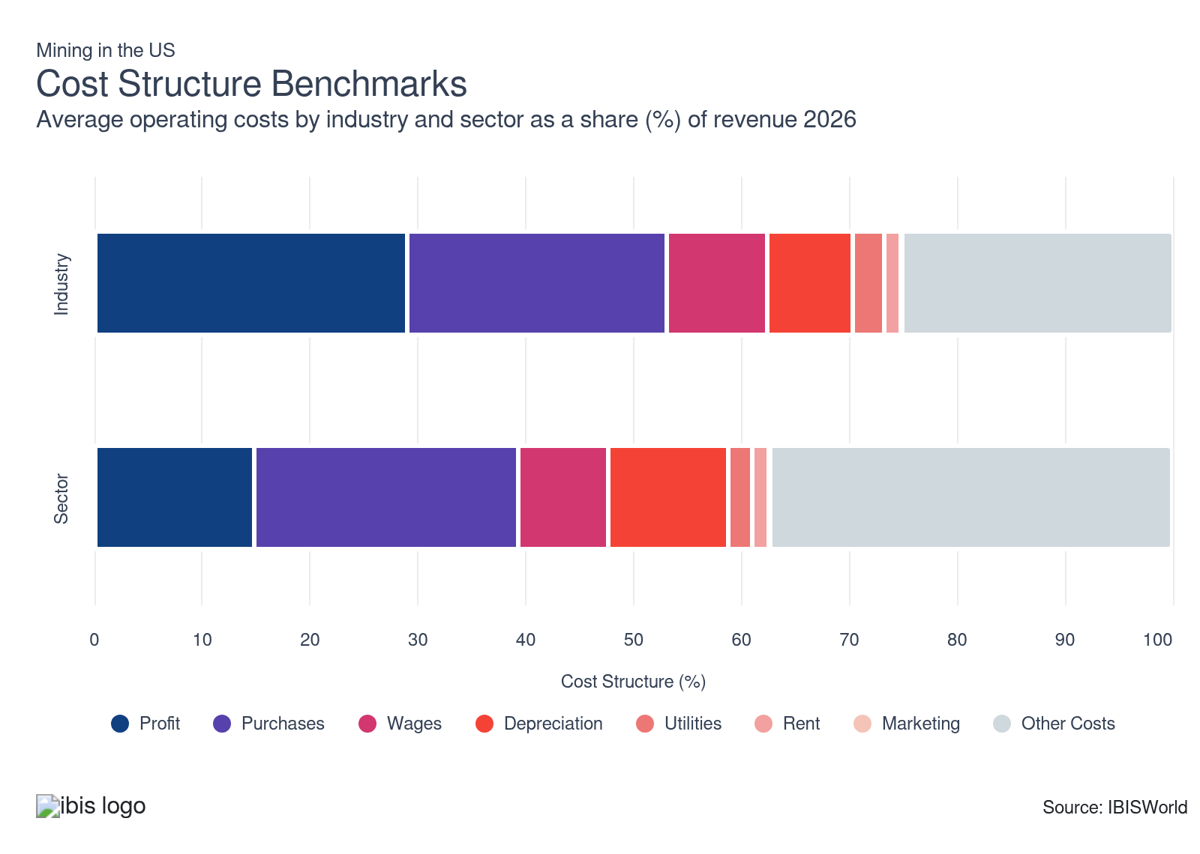
Chart displays current year only in the PDF version of this report. You can view and download chart for all other years associated with this industry on my.ibisworld.com.

What trends impact industry costs?

Commodity prices can drastically swing profit
- Upticks in the price of commodities can swing profitability. When the price swells, it does expand the costs associated with operating heavy machinery, but some mining companies can pass these costs down to customers and bolster their profit.
- Profit has swelled as commodity prices like oil and gas expanded after lockdown restrictions were lifted, accounting for almost a third of revenue. Nonetheless, profit has dipped from a period-high peak of 32.2% in 2022, where commodity prices were at their highest. As supply chain issues dwindled, prices gradually crept down, pushing down profit.

Wage costs vary for miners
- Wage costs can vary depending on the specific type of commodity or mineral being mined or extracted. While average salaries for employees remain elevated, the high demand commodities like oil and gas have caused profit to swell, keeping the wage share of revenue steady.
- Highly skilled coal miners and oil field services workers account for a much greater share of total revenue than in most mining industries. Oil and gas extractors' wage costs remain low because of the reliance on automation and technical advancements. Advanced robotics has also limited the reliance on labor for dangerous tasks.

Purchase costs surge alongside commodities and interest rates
- Purchases remain the largest expense for companies in the mining sector, accounting for almost a quarter of industry revenue. Purchase costs include a range of machinery, chemicals, underground well infrastructure, explosives, blades, cartage, drilling and cementing equipment and other consumable parts.
- The prices of steel and aluminum impact the cost of the machinery and equipment necessary to purchase mining equipment. The world price of both metals has skyrocketed in recent years, keeping purchase costs elevated. High interest rates have also kept purchase costs high, as new machinery and facility upgrades are often financed through credit. Even so, rates eventually pushed down after peaking in the middle of 2024, slightly reducing purchases late in the period.

Depreciation costs remain moderate as equipment requires repairs
- Depreciation typically accounts for a moderate portion of total sector revenue, as capital expenditure is very high in the sector. Some mining operations operate 24 hours a day, year-round, so machinery and equipment depreciate at a much faster rate than in other sectors.
- Depreciation expenses are set to remain stable throughout 2026, reflecting trends in overall commodity prices. Miners that rely on outdated or faulty equipment risk reducing production efficiency, potentially triggering ripple effects across the entire supply chain. This is why equipment constantly gets replaced.

Rent is typically small but has its purposes
- Rent costs account for the second-smallest expense for the mining sector. Rent costs are typically low because most miners own the land where they operate. Occasionally, some mining companies will rent equipment rather than purchase it if the project is short-term. Most oil and gas companies own the extraction sites, so they don't rent out any land for projects.
- Some companies in the sector rent commercial buildings for their headquarters or administrative work. However, many large corporations typically own their buildings rather than rent them.

Utility costs can vary based on the scale of production
- Utility costs account for a moderate share of revenue. Oil drilling, gas extraction and mining are energy-intensive, consuming substantial electricity and fuel, especially since many sites run around the clock to maximize output.
- Utility costs typically depend on how big or small a company is. Even so, companies that are much larger in scale can get lower utility rates since they purchase electricity in bulk. Although many mining processes require substantial energy inputs, the proportion of energy expenditure is usually modest when compared with the overall operational scale and revenue they generate.

Marketing is not essential at all for the mining sector
- Marketing costs constitute a very minimal share of total sector revenue and have remained steady through 2025. These costs remain low since all the commodities extracted are essential to the economy and do not require additional marketing.
- Companies in this sector primarily engage in business-to-business transactions, where relationships and contracts are more important than traditional advertising. Most companies have long-term sales contracts in place, so they have a steady stream of revenue without relying on marketing.
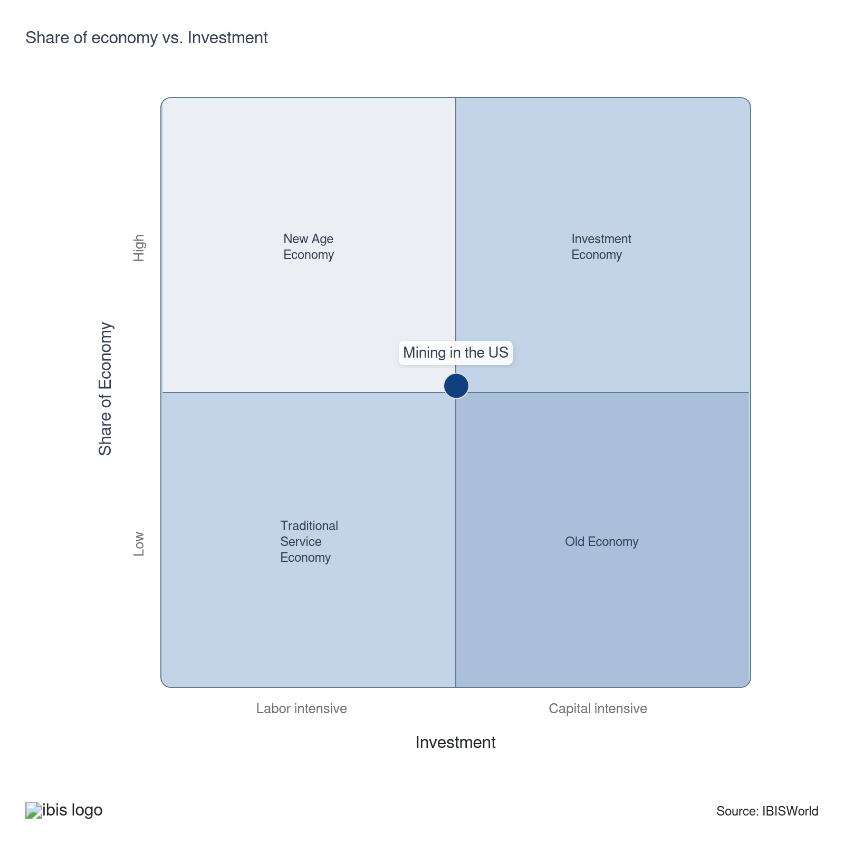

Key Ratios
Year | Revenue per Employee  ($) | Revenue per Enterprise  ($ Million) | Employees per Estab.  (Units) | Employees per Enterprise  (Units) | Average Wage  ($) | Wages/ Revenue  (%) | Estab. per Enterprise  (Units) | IVA/ Revenue  (%) | Imports/ Demand  (%) | Exports/ Revenue  (%)
2005 | 1,044,560 | 5.4 | 4.9 | 5.2 | 84,429 | 8.1 | 1.0 | 38.5 | 33.5 | 3.2
2006 | 955,007 | 5.3 | 5.3 | 5.5 | 90,663 | 9.5 | 1.0 | 38.6 | 36.5 | 3.5
2007 | 840,270 | 5.7 | 6.5 | 6.8 | 77,621 | 9.2 | 1.0 | 35.7 | 35.8 | 3.8
2008 | 1,137,285 | 6.6 | 5.6 | 5.8 | 97,437 | 8.6 | 1.0 | 36.4 | 38.5 | 4.4
2009 | 772,760 | 4.6 | 5.7 | 6.0 | 88,935 | 11.5 | 1.1 | 33.8 | 34.3 | 4.6
2010 | 933,000 | 5.2 | 5.3 | 5.6 | 99,505 | 10.7 | 1.0 | 35.2 | 36.4 | 6.0
2011 | 1,003,166 | 6.0 | 5.7 | 6.0 | 105,359 | 10.5 | 1.1 | 38.1 | 36.8 | 7.0
2012 | 933,207 | 6.1 | 6.2 | 6.5 | 104,179 | 11.2 | 1.1 | 37.7 | 33.6 | 6.3
2013 | 1,012,358 | 6.8 | 6.4 | 6.7 | 107,945 | 10.7 | 1.1 | 34.9 | 28.6 | 6.2
2014 | 1,062,213 | 7.2 | 6.4 | 6.7 | 111,671 | 10.5 | 1.1 | 36.9 | 24.7 | 7.0
2015 | 735,701 | 5.3 | 6.8 | 7.2 | 99,706 | 13.6 | 1.1 | 43.7 | 21.4 | 7.4
2016 | 751,283 | 4.9 | 6.1 | 6.5 | 99,024 | 13.2 | 1.1 | 36.2 | 21.2 | 9.1
2017 | 893,333 | 5.7 | 6.0 | 6.4 | 100,865 | 11.3 | 1.1 | 47.6 | 24.2 | 13.9
2018 | 1,087,234 | 7.6 | 6.6 | 7.0 | 107,918 | 9.9 | 1.1 | 37.5 | 23.7 | 16.6
2019 | 1,029,154 | 7.7 | 7.1 | 7.5 | 107,454 | 10.4 | 1.1 | 36.6 | 21.9 | 19.7
2020 | 796,642 | 6.3 | 7.4 | 7.9 | 96,121 | 12.1 | 1.1 | 35.2 | 20.7 | 23.4
2021 | 1,341,289 | 8.5 | 5.9 | 6.3 | 104,639 | 7.8 | 1.1 | 42.1 | 23.8 | 25.1
2022 | 1,715,051 | 11.0 | 6.1 | 6.4 | 106,949 | 6.2 | 1.1 | 46.6 | 24.5 | 26.5
2023 | 1,234,477 | 9.1 | 6.9 | 7.4 | 110,468 | 8.9 | 1.1 | 45.9 | 25.4 | 28.7
2024 | 1,193,939 | 8.9 | 7.1 | 7.5 | 110,138 | 9.2 | 1.1 | 46.0 | 25.6 | 28.7
2025 | 1,208,051 | 9.1 | 7.1 | 7.5 | 110,376 | 9.1 | 1.1 | 46.3 | 25.4 | 28.4
2026 | 1,162,942 | 8.9 | 7.2 | 7.6 | 107,986 | 9.3 | 1.1 | 46.2 | 25.1 | 28.7
2027 | 1,165,403 | 8.9 | 7.2 | 7.7 | 108,032 | 9.3 | 1.1 | 46.3 | 25.0 | 28.8
2028 | 1,165,837 | 8.9 | 7.2 | 7.7 | 108,039 | 9.3 | 1.1 | 46.2 | 25.0 | 28.8
2029 | 1,166,768 | 9.1 | 7.3 | 7.8 | 108,057 | 9.3 | 1.1 | 46.3 | 25.0 | 28.9
2030 | 1,172,895 | 9.2 | 7.4 | 7.9 | 108,170 | 9.2 | 1.1 | 46.3 | 24.9 | 28.9
2031 | 1,180,701 | 9.4 | 7.5 | 8.0 | 108,314 | 9.2 | 1.1 | 46.4 | 25.0 | 28.8
2032 | 1,185,452 | 9.5 | 7.5 | 8.0 | 108,401 | 9.1 | 1.1 | 46.5 | 25.0 | 28.7
*Figures are inflation adjusted to 2026
*Figures are inflation adjusted to 2026

10. Key Statistics
https://my.ibisworld.com/us/en/industry/21/key-statistics

Industry Data

Values
Year | Revenue  ($ Million) | IVA  ($ Million) | Estab.  (Units) | Enterprises  (Units) | Employment  (Units) | Exports  ($ Million) | Imports  ($ Million) | Wages  ($ Million)
2005 | 618,639.7 | 238,288.1 | 119,673 | 114,599 | 592,249 | 20,054.5 | 301,921.4 | 50,002.9
2006 | 622,467.7 | 240,307.4 | 123,216 | 117,769 | 651,794 | 21,656.0 | 344,770.9 | 59,093.6
2007 | 669,979.9 | 239,474.6 | 122,654 | 117,369 | 797,339 | 25,476.8 | 358,623.6 | 61,890.0
2008 | 833,770.8 | 303,648.8 | 131,293 | 125,389 | 733,124 | 36,469.4 | 499,366.3 | 71,433.1
2009 | 542,024.7 | 182,987.8 | 123,658 | 117,758 | 701,414 | 25,185.6 | 269,413.7 | 62,380.4
2010 | 636,981.5 | 223,994.6 | 128,234 | 122,170 | 682,724 | 38,373.9 | 342,251.8 | 67,934.1
2011 | 758,405.8 | 288,972.5 | 132,830 | 126,456 | 756,012 | 53,459.0 | 409,814.8 | 79,652.6
2012 | 777,037.6 | 292,660.3 | 133,936 | 127,447 | 832,653 | 48,905.2 | 369,184.3 | 86,745.3
2013 | 844,307.8 | 294,348.3 | 130,535 | 124,048 | 834,001 | 52,007.3 | 317,028.6 | 90,026.0
2014 | 917,833.6 | 338,800.2 | 134,860 | 128,142 | 864,077 | 64,683.9 | 279,596.0 | 96,492.2
2015 | 615,900.4 | 268,855.9 | 122,726 | 115,837 | 837,161 | 45,785.5 | 155,281.4 | 83,469.8
2016 | 502,723.4 | 181,888.6 | 109,370 | 102,698 | 669,153 | 45,640.9 | 123,173.4 | 66,262.3
2017 | 591,555.1 | 281,526.4 | 109,823 | 103,513 | 662,189 | 82,013.4 | 162,684.9 | 66,792.0
2018 | 743,184.4 | 278,886.9 | 103,450 | 97,266 | 683,555 | 123,718.2 | 192,226.8 | 73,768.0
2019 | 721,527.3 | 264,375.2 | 99,425 | 93,306 | 701,088 | 142,086.5 | 162,670.8 | 75,335.0
2020 | 510,792.7 | 179,679.2 | 87,169 | 81,273 | 641,182 | 119,435.5 | 102,309.3 | 61,631.0
2021 | 728,643.2 | 306,632.7 | 91,412 | 85,768 | 543,241 | 183,014.8 | 169,985.4 | 56,844.4
2022 | 996,159.7 | 464,591.2 | 95,991 | 90,373 | 580,834 | 264,462.6 | 237,726.4 | 62,119.4
2023 | 764,430.1 | 351,193.0 | 89,337 | 84,241 | 619,234 | 219,609.1 | 185,608.1 | 68,405.8
2024 | 731,960.0 | 337,041.9 | 86,942 | 81,912 | 613,063 | 209,716.4 | 179,665.7 | 67,521.3
2025 | 724,526.0 | 335,378.2 | 84,663 | 79,658 | 599,748 | 205,740.2 | 176,259.2 | 66,197.8
2026 | 686,610.0 | 317,273.3 | 82,216 | 77,270 | 590,408 | 196,924.7 | 164,149.0 | 63,755.7
2027 | 675,400.2 | 312,739.3 | 80,441 | 75,577 | 579,542 | 194,639.0 | 160,126.7 | 62,608.8
2028 | 668,486.1 | 309,140.0 | 79,601 | 74,796 | 573,396 | 192,766.8 | 158,315.7 | 61,949.4
2029 | 668,909.2 | 309,445.2 | 78,712 | 73,904 | 573,301 | 193,009.2 | 158,244.1 | 61,949.1
2030 | 672,299.8 | 311,309.2 | 77,560 | 72,722 | 573,197 | 194,108.6 | 158,873.7 | 62,002.9
2031 | 676,645.3 | 314,062.8 | 76,831 | 71,956 | 573,088 | 194,658.2 | 160,905.6 | 62,073.6
2032 | 676,645.3 | 314,508.2 | 76,025 | 71,145 | 570,791 | 194,505.7 | 161,124.8 | 61,874.6

*Figures are inflation adjusted to 2026

Annual Change
Year | Revenue  % | IVA  % | Estab.  % | Enterprises  % | Employment  % | Exports  % | Imports  % | Wages  %
2005 | N/A | N/A | N/A | N/A | N/A | N/A | N/A | N/A
2006 | 0.6 | 0.8 | 3.0 | 2.8 | 10.1 | 8.0 | 14.2 | 18.2
2007 | 7.6 | -0.3 | -0.5 | -0.3 | 22.3 | 17.6 | 4.0 | 4.7
2008 | 24.4 | 26.8 | 7.0 | 6.8 | -8.1 | 43.1 | 39.2 | 15.4
2009 | -35.0 | -39.7 | -5.8 | -6.1 | -4.3 | -30.9 | -46.0 | -12.7
2010 | 17.5 | 22.4 | 3.7 | 3.7 | -2.7 | 52.4 | 27.0 | 8.9
2011 | 19.1 | 29.0 | 3.6 | 3.5 | 10.7 | 39.3 | 19.7 | 17.2
2012 | 2.5 | 1.3 | 0.8 | 0.8 | 10.1 | -8.5 | -9.9 | 8.9
2013 | 8.7 | 0.6 | -2.5 | -2.7 | 0.2 | 6.3 | -14.1 | 3.8
2014 | 8.7 | 15.1 | 3.3 | 3.3 | 3.6 | 24.4 | -11.8 | 7.2
2015 | -32.9 | -20.6 | -9.0 | -9.6 | -3.1 | -29.2 | -44.5 | -13.5
2016 | -18.4 | -32.3 | -10.9 | -11.3 | -20.1 | -0.3 | -20.7 | -20.6
2017 | 17.7 | 54.8 | 0.4 | 0.8 | -1.0 | 79.7 | 32.1 | 0.8
2018 | 25.6 | -0.9 | -5.8 | -6.0 | 3.2 | 50.9 | 18.2 | 10.4
2019 | -2.9 | -5.2 | -3.9 | -4.1 | 2.6 | 14.8 | -15.4 | 2.1
2020 | -29.2 | -32.0 | -12.3 | -12.9 | -8.5 | -15.9 | -37.1 | -18.2
2021 | 42.6 | 70.7 | 4.9 | 5.5 | -15.3 | 53.2 | 66.1 | -7.8
2022 | 36.7 | 51.5 | 5.0 | 5.4 | 6.9 | 44.5 | 39.9 | 9.3
2023 | -23.3 | -24.4 | -6.9 | -6.8 | 6.6 | -17.0 | -21.9 | 10.1
2024 | -4.2 | -4.0 | -2.7 | -2.8 | -1.0 | -4.5 | -3.2 | -1.3
2025 | -1.0 | -0.5 | -2.6 | -2.8 | -2.2 | -1.9 | -1.9 | -2.0
2026 | -5.2 | -5.4 | -2.9 | -3.0 | -1.6 | -4.3 | -6.9 | -3.7
2027 | -1.6 | -1.4 | -2.2 | -2.2 | -1.8 | -1.2 | -2.5 | -1.8
2028 | -1.0 | -1.2 | -1.0 | -1.0 | -1.1 | -1.0 | -1.1 | -1.1
2029 | 0.1 | 0.1 | -1.1 | -1.2 | 0.0 | 0.1 | 0.0 | 0.0
2030 | 0.5 | 0.6 | -1.5 | -1.6 | 0.0 | 0.6 | 0.4 | 0.1
2031 | 0.6 | 0.9 | -0.9 | -1.1 | 0.0 | 0.3 | 1.3 | 0.1
2032 | 0.0 | 0.1 | -1.0 | -1.1 | -0.4 | -0.1 | 0.1 | -0.3

*Figures are inflation adjusted to 2026

DISCLAIMER
This product has been supplied by IBISWorld Inc. (‘IBISWorld’) solely for use by its authorized licenses strictly in accordance with their license agreements with IBISWorld. IBISWorld makes no representation to any other person with regard to the completeness or accuracy of the data or information contained herein, and it accepts no responsibility and disclaims all liability (save for liability which cannot be lawfully disclaimed) for loss or damage whatsoever suffered or incurred by any other person resulting from the use of, or reliance upon, the data or information contained herein. Copyright in this publication is owned by IBISWorld Inc. The publication is sold on the basis that the purchaser agrees not to copy the material contained within it for other than the purchasers own purposes. In the event that the purchaser uses or quotes from the material in this publication – in papers, reports, or opinions prepared for any other person – it is agreed that it will be sourced to: IBISWorld Inc.

